Software Engineering

2022/23

Gantt Project

Mergedoc deliverable

Phase 2 Final Report

Repository:

https://github.com/ddiask/SE2223_59731_60127_60590_60811_64862

Students:

* Diogo Dias, 59731, P4
* João Ribeiro, 60127, P6
* Pedro Gasparinho, 60590, P2
* Tiago Meirim, 60811, P2
* Afonso Nunes, 64862, P2

Note: The following pieces of artefacts refer to their latest version, while some reviews refer to a prior version. This explains possible incompatibilities between what was originally reviewed and what is being showcased in this report.

Chapter 1 - Patterns

Diogo Dias’ Patterns

Pattern 1 - Façade

Location - ganttproject\ganttproject\src\main\java\net\sourceforge\ganttproject\gui\UIfacade

Motive - In this case, UIFacade is an interface that combines features that share a common goal, particularly, to show a message on screen. This interface can offer an abstraction of these features that can be used in the system, without knowing the complexity of the implementation.

Code snippet -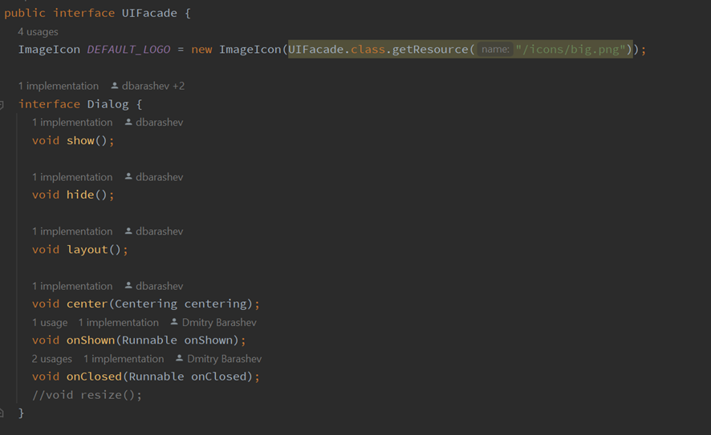

Pattern 2 - Proxy

Location - ganttproject\src\main\java\net\sourceforge\ganttproject\document\ProxyDocument.java

Motive - The proxyDocument class is a simplified implementation of the Document interface. It delegates some requests to other non-proxy Document objects that can fulfill them, for example the getFileName() method, which returns the document's name using another class that extends Document. The proxyDocument class can also perform some tasks by itself, such as the write() method, which writes bytes in a file.

Code snippet -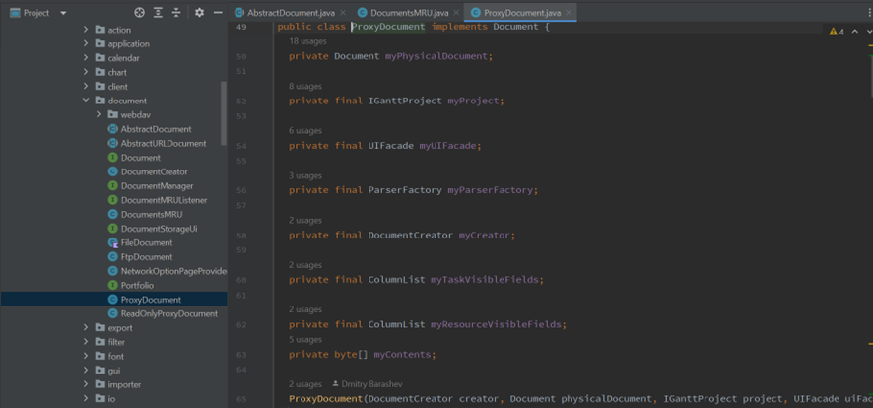

Pattern 3 - Memento Pattern

Location - ganttproject\src\main\java\net\sourceforge\ganttproject\undo\UndoableEditImpl.java

Motive - This class allows the user to save his document or require an old version of his document.

Code snippet -

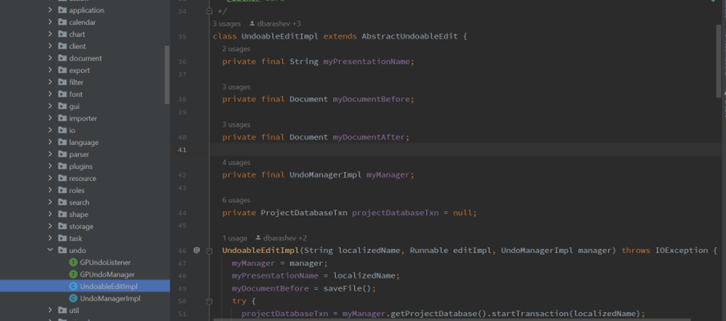

João Ribeiro’s Patterns

Pattern 1 - Builder

Location - ganttproject/src/main/java/net/sourceforge/ganttproject/gui/options/OptionsPageBuilder.java

Motive - OptionsPageBuilder is a builder class that allows the construction of complex and different objects step by step using the same construction code.

Code snippet -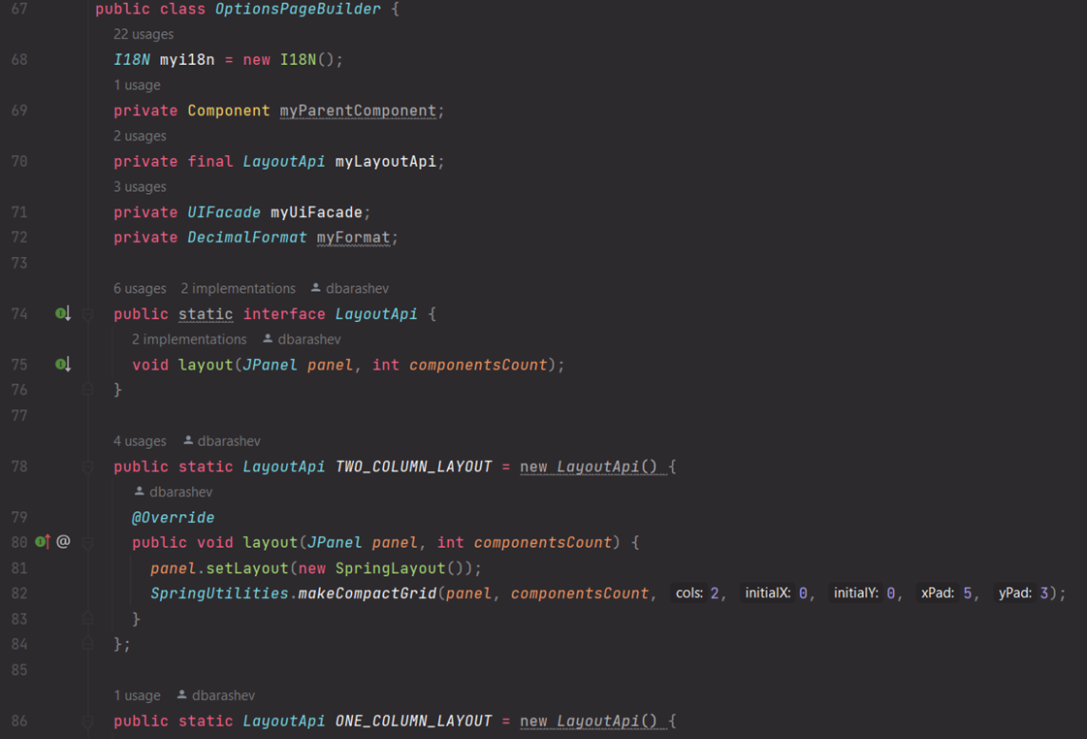

Pattern 2 - Prototype

Location - ganttproject/src/main/java/net/sourceforge/ganttproject/gui/EditableList.java

Motive - This method, located in the EditableList class, allows for the creation of copies of existing objects without making the code dependent on their original classes.

Code snippet -

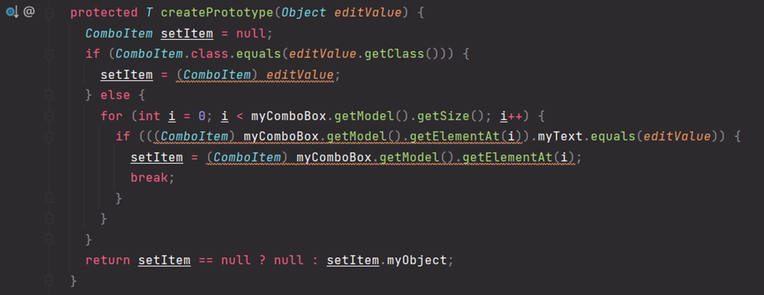

Pattern 3 - Proxy

Location - ganttproject/src/main/java/net/sourceforge/ganttproject/document/ReadOnlyProxyDocument.java

Motive - ReadOnlyProxyDocument is a proxy class that permits the usage of itself in order to allow other classes of the Document type to be used in codes that normally wouldn’t be accepted. For example, this proxy is used to surround a Document in the usage of the openProject() method inside the recover method in the HelpMenu class.

Code snippet - 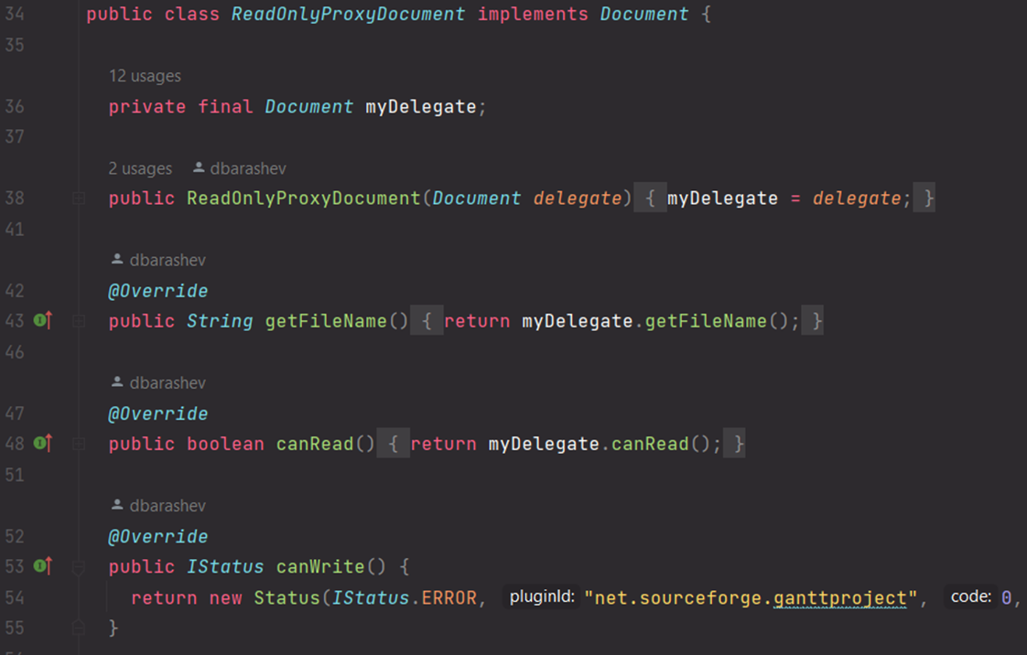

Pedro Gasparinho’s Patterns

Pattern 1 - Factory

Location - ganttproject\biz.ganttproject.core\src\main\java\biz.ganttproject\core\time\CalenderFactory.

Motive - This abstract class is used to create GanttCalenders given different arguments. This helps to hide the complete process behind the creation of a GanttCalender to the user, starting off with a predefined localeApi, but also giving the possibility to change localeApi’s for users with more knowledge about the system.

Code snippet - 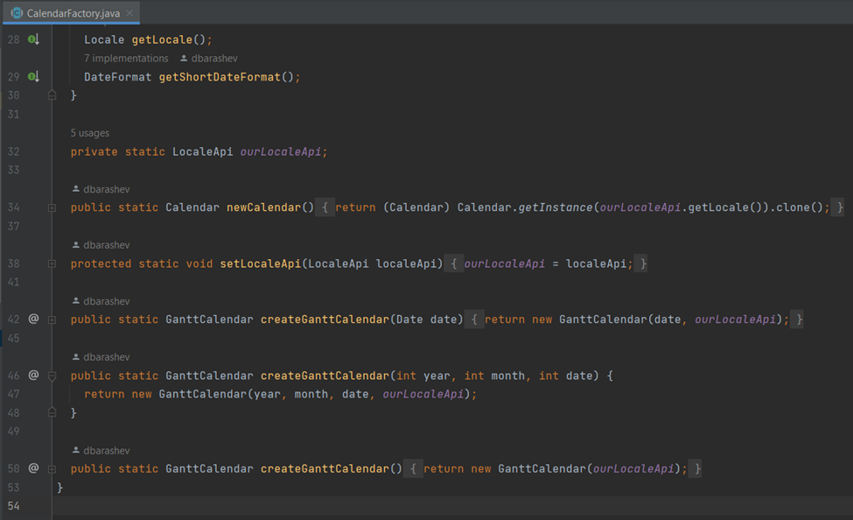

Pattern 2 - Façade

Location - ganttproject\ganttproject\src\main\java\net.sourceforge.ganttproject\export\ConsoleUIFacade

Motive - ConsoleUIFacade is a façade class used to hide complex details about the system while also formatting the outputs and other functionalities in a more user-friendly way to be used in the console UI.

Code snippet -

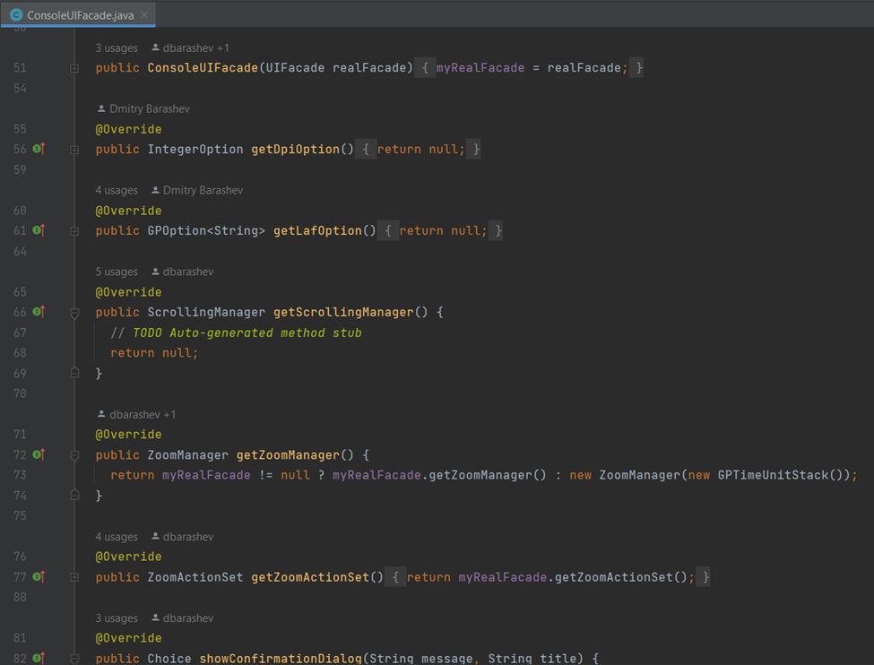

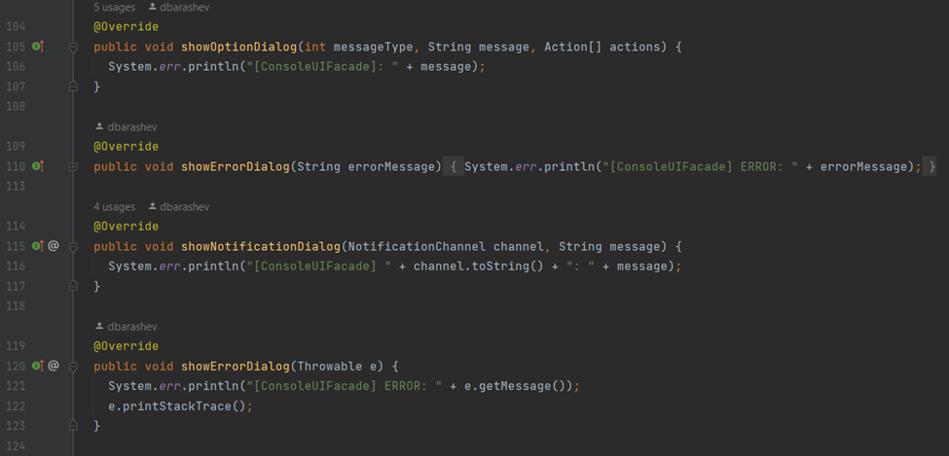

Pattern 3 - Adapter

Location - ganttproject\ganttproject\src\main\java\net.sourceforge.ganttproject\gui\options\model\CustomPropertyDefaultValueAdapter

Motive - Given a CustomPropertyClass object and a CustomPropertyDefinition object this class implements the ability to adapt the default value from the CustomPropertyDefinition object to a GPOption implemented class base on a primitive type given by the CustomPropertyClass object. While also providing a commit and a setValue method.

Code snippet -

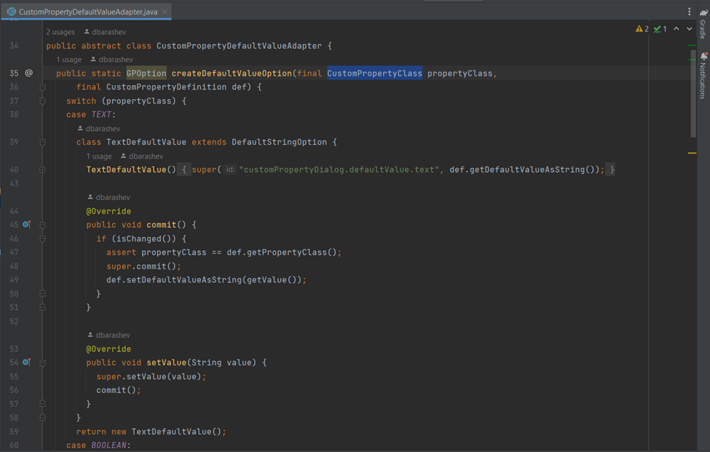

Tiago Meirim’s Patterns

Pattern 1 - Builder

Location - biz.ganttproject.core/src/main/java/biz/ganttproject/core/chart/grid/OffsetBuilderImpl.java

Motive - Although this pattern is not yet explored and explained by the teacher, with a little googling I found that this class fit perfectly in the builder pattern. The class lets you build the different types of objects offsets step by step, like the method constructOffsets, by exporting the object construction code, in this case from the offset, and using it in the object builders/constructors.

Code snippet - 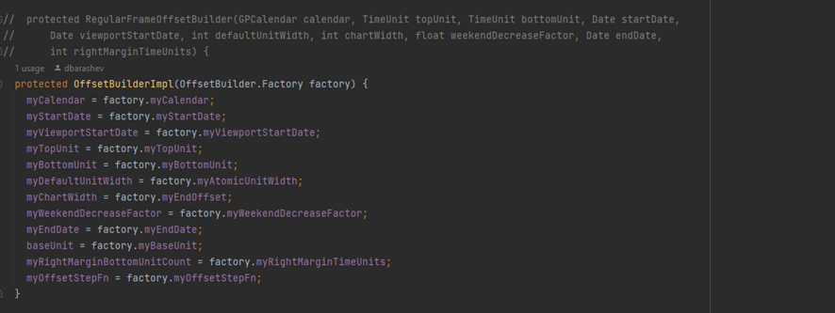

Pattern 2 - Façade

Location - biz.ganttproject.core/src/main/java/biz/ganttproject/core/chart/grid/OffsetLookup.java

Motive - The class creates other comparator classes that implement the same interface but for different types that are used as arguments when creating the class. Because both classes use the same name to compare the only difference between them is the type.

Code snippet - 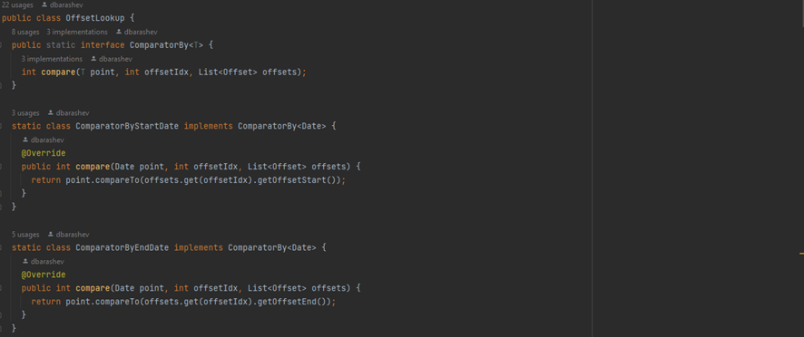

Pattern 3 - Factory

Location - biz.ganttproject.core/src/main/java/biz/ganttproject/core/chart/grid/OffsetBuilderImpl.java

Motive - This class is hiding the creation of instances of the given type behind an interface, so the client doesn’t depend on concrete classes and one class can be easily replaceable or added. In this specific implementation the class builds grid offsets for timelines where top cells are always constructed from the integer number of bottom cells.

Code snippet - 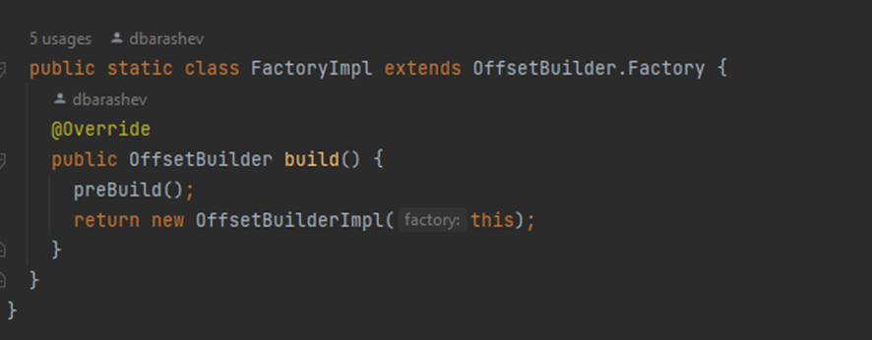

Afonso Nunes’s Patterns

Pattern 1 - Façade

Location - ganttproject/src/main/java/net/sourceforge/ganttproject/task/TaskContainmentHierarchyFacade.java

Motive - After a discussion with my colleague and reviewing the code a little bit more I came to terms with his review and can also agree that this interface is indeed used to encapsulate Tasks whose implementation is done in a tree and not any type of Task.

Code snippet -

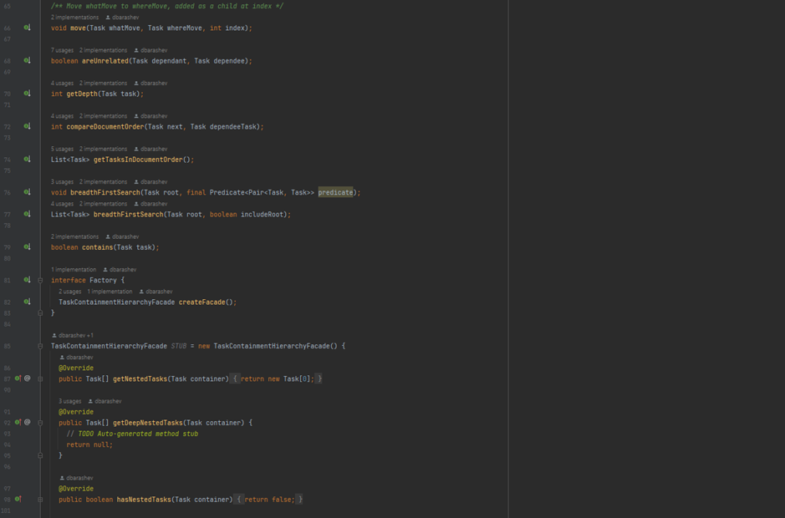

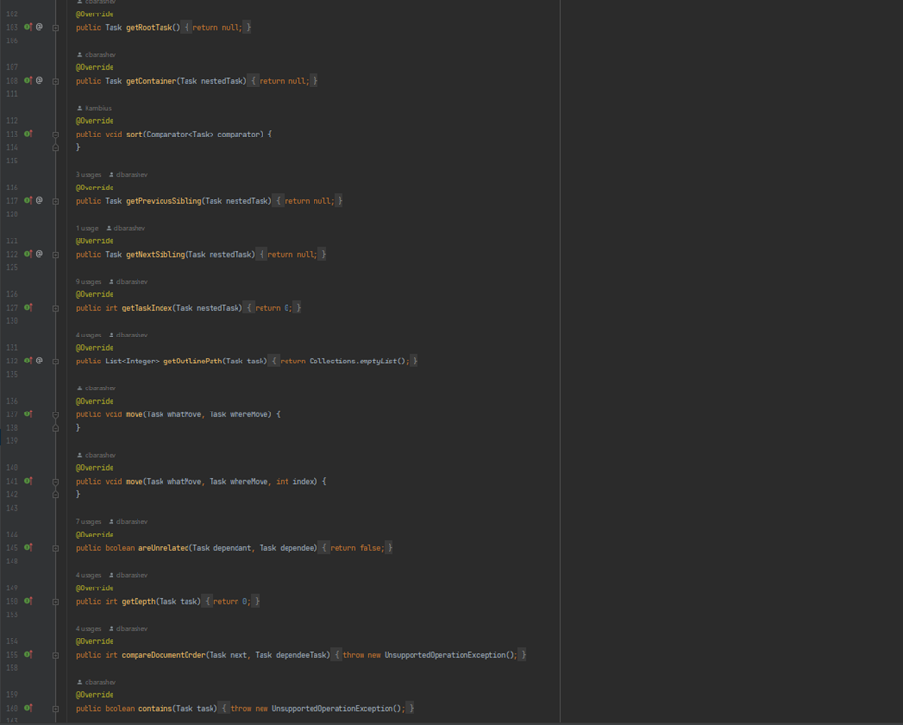

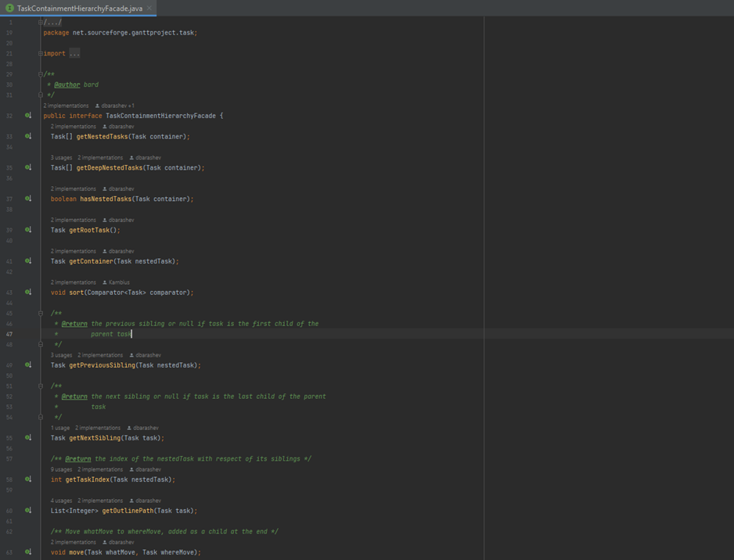

Pattern 2 - Factory

Location - ganttproject/src/main/java/net/sourceforge/ganttproject/parser/ParserFactory.java

Motive - This interface is used to hide the creation of instances of type Parser behind it making it so we can replace the concrete parser classes with others if we need to and it has no impact on the client code.

Code snippet - 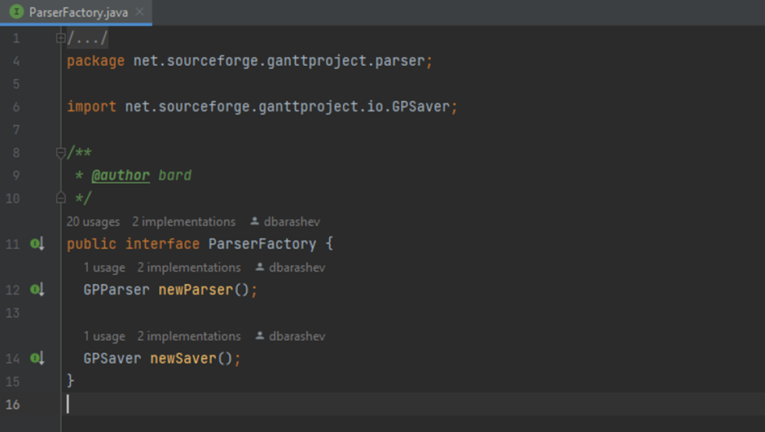

Pattern 3 - Command

Location - ganttproject/src/main/java/net/sourceforge/ganttproject/action/edit

Motive - Since I didn’t specify any of the operations, I can understand my colleague's review. As it can be **seen** **from** **the** **screenshots** there are many operations supported in this implementation of the command pattern and that are useful for the user.

Code snippet -

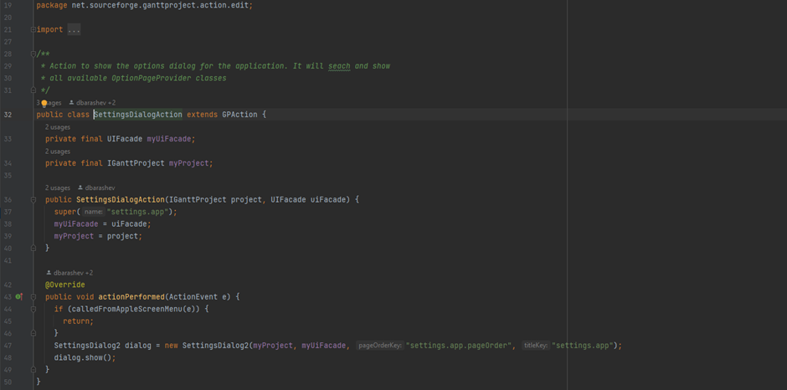

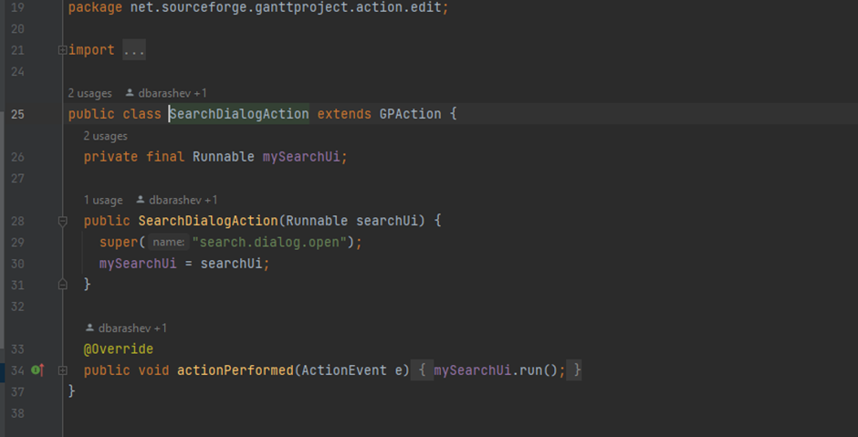

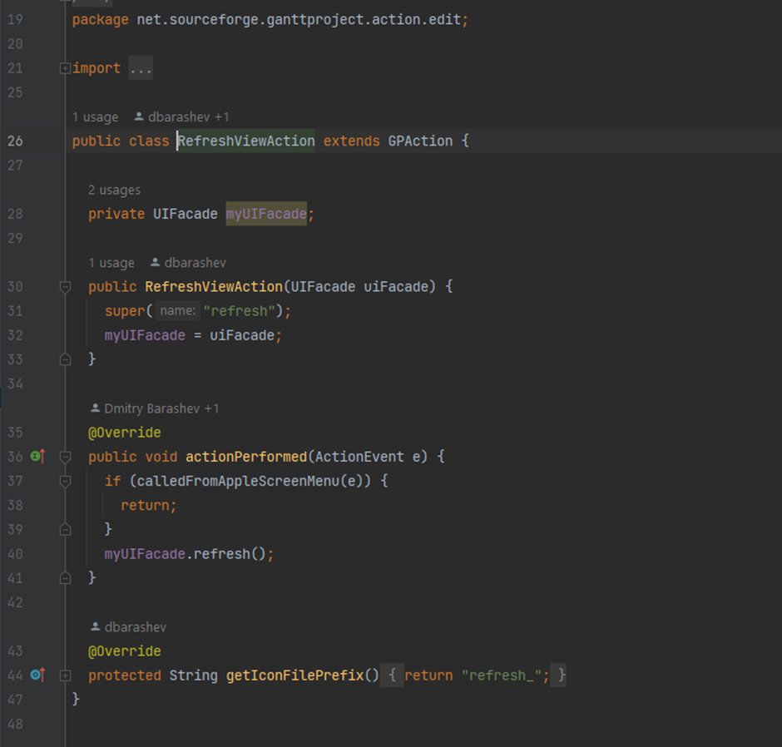

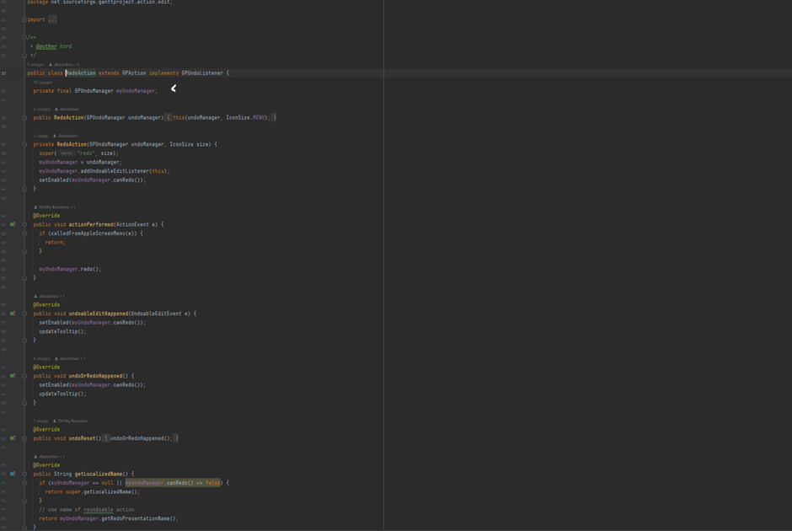

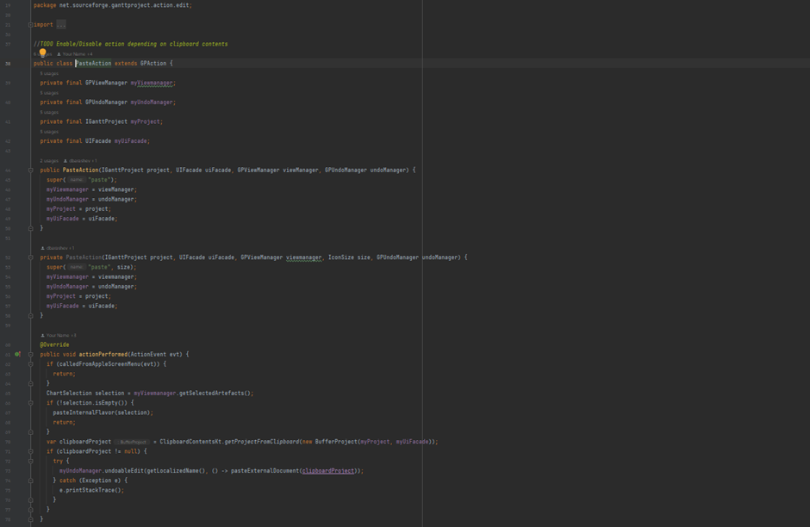

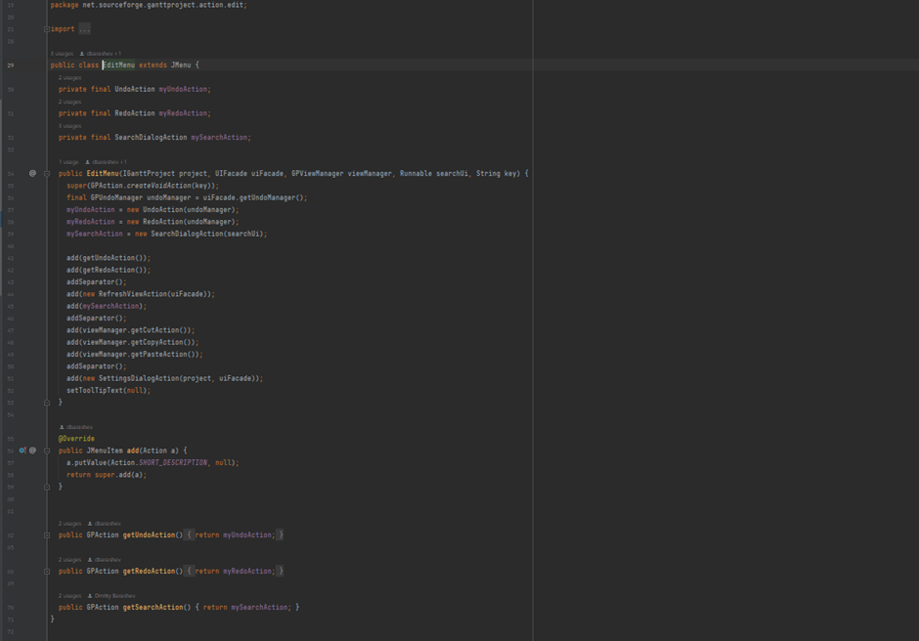

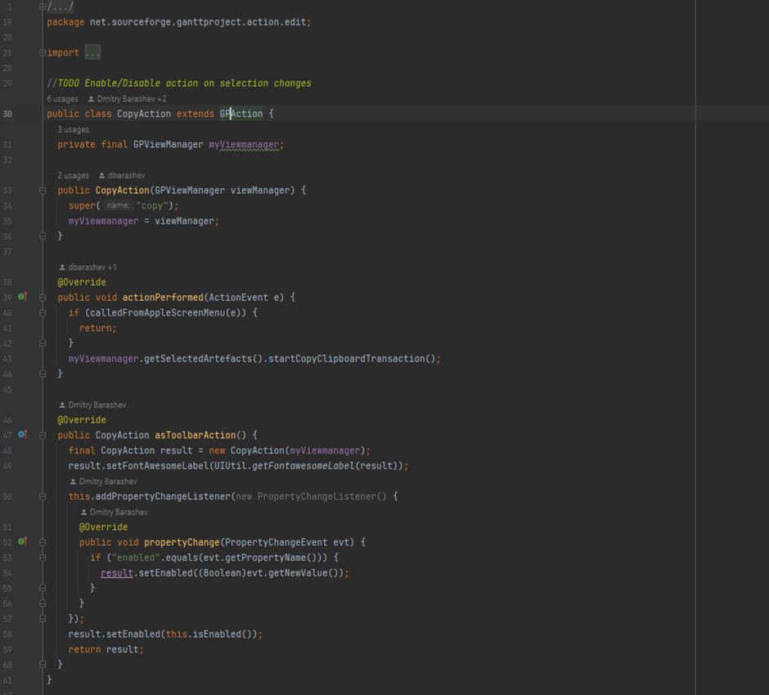

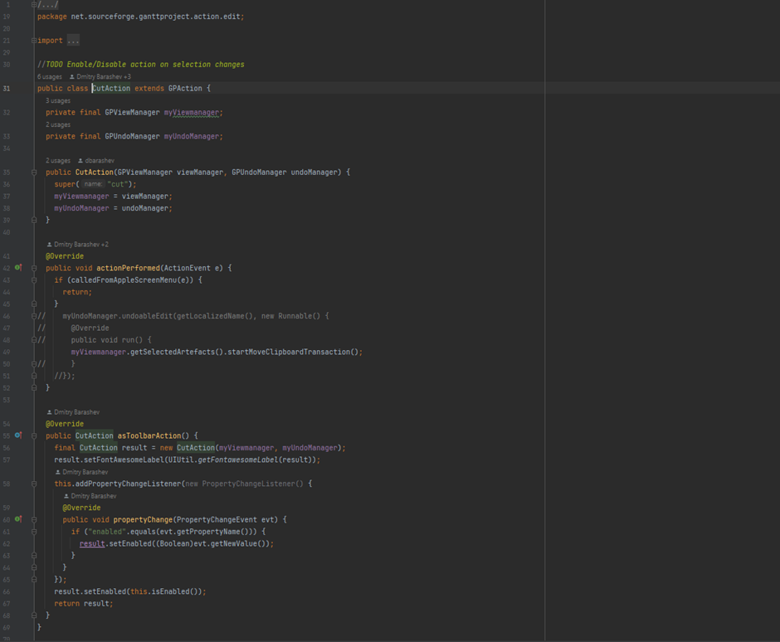

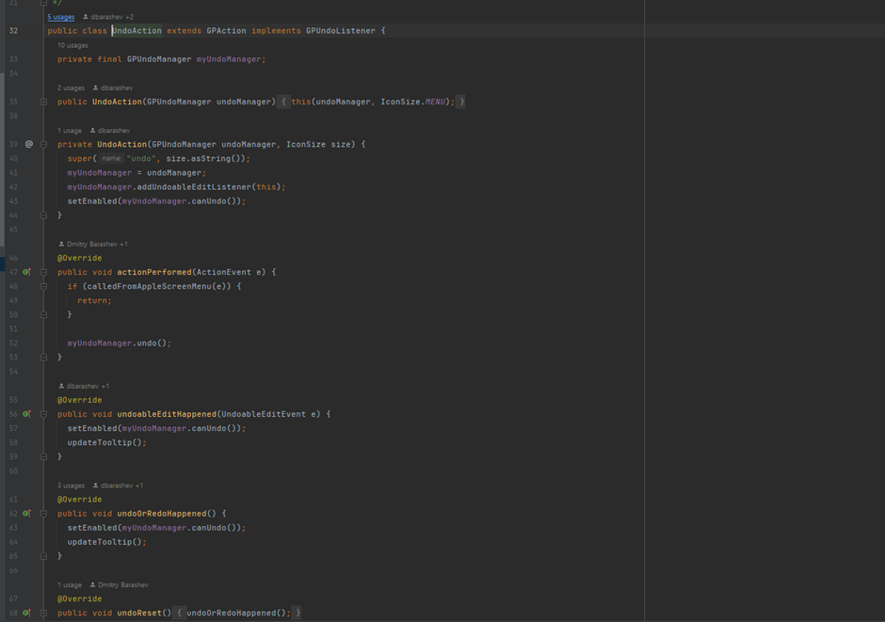

Chapter 2 - Code Smells

Diogo Dias’ Code Smells

Code Smell 1 - Duplicated Code

Location:

* biz.ganttproject.core\src\main\java\biz\ganttproject\core\chart\render\RectangleRenderer.java
* biz.ganttproject.core\src\main\java\biz\ganttproject\core\chart\render\PolygonRenderer.java
* biz.ganttproject.core\src\main\java\biz\ganttproject\core\chart\render\LineRenderer.java
* biz.ganttproject.core\src\main\java\biz\ganttproject\core\chart\render\SummaryTaskRenderer.java

Motive - All these classes have the same variables, one method equal and one method that is different in each class but has the same name and same purpose.

Solution - It’s possible to eliminate this repetition using an abstract class, AbstractRenderer. This class should have the variables myProperties and myGraphics. In terms of methods, this class implements the method setGraphics and may have an abstract method, render, that allows each class’ son to implement this method.

Code snippet -

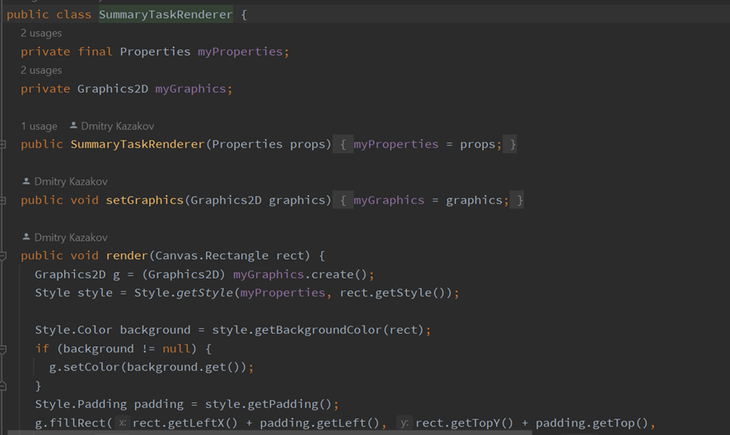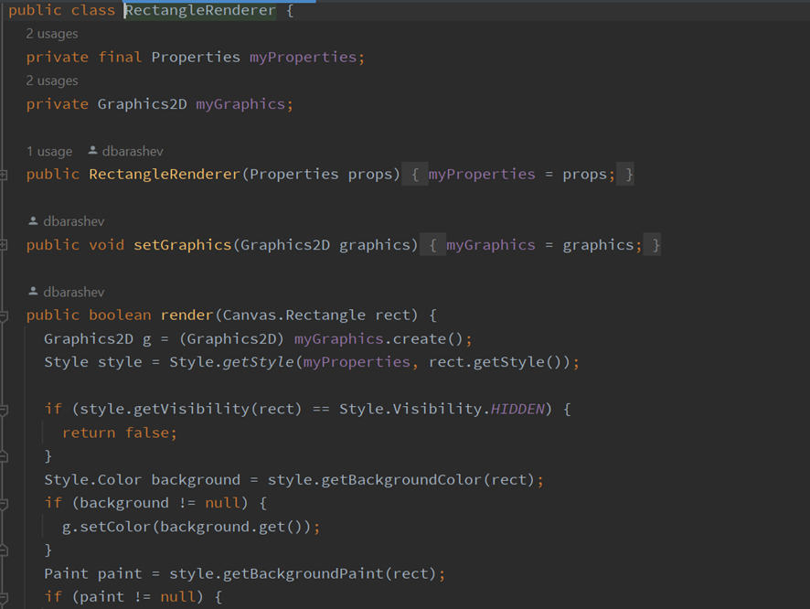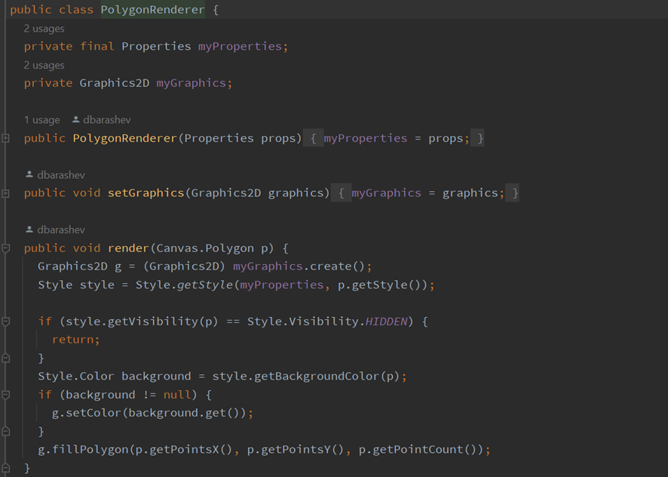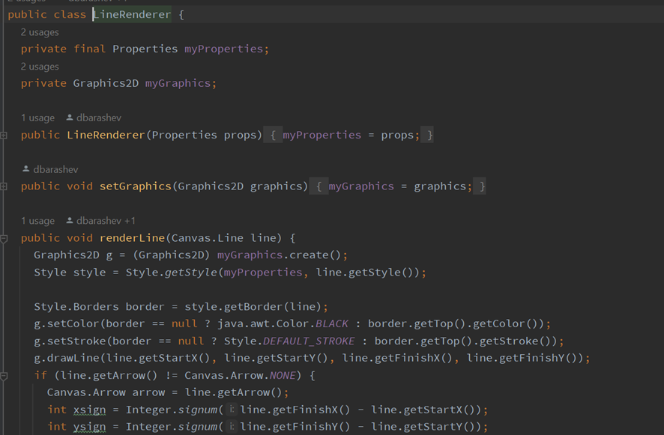

Code Smell 2 - Message Chain

Location - ganttproject\src\main\java\net\sourceforge\ganttproject\export\ExporterToCSV.java

Motive - This method is calling in chains methods that return other objects. The method getProject returns an IGanttProject. After that is called the method getGanttOptions that is implemented in IGanttProject, this method returns a GanttOptions. Finally, the object GanttOptions calls the method getCSVOptions which returns a CSVOptions object.

Solution - The way to resolve this problem the class IGanttProject may have a method that returns a CSVOptions object. After that, the class ExporterToCSV should use the method created in IGanttProject and create a new method that also returns CSVOptions. So we can use the class that we pretend to without knowing the complexity of the system.

Code snippet -

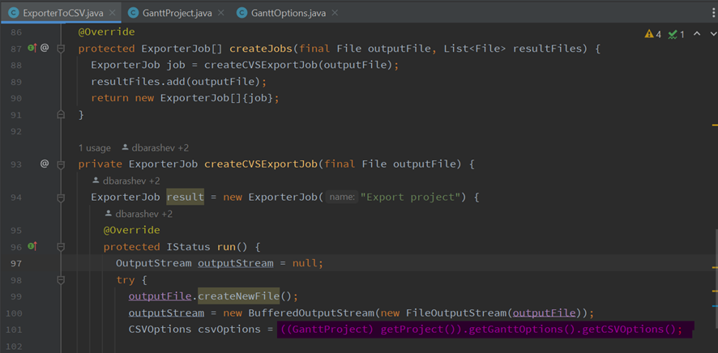

Code Smell 3 - Speculative Generality

Location - ganttproject\src\main\java\net\sourceforge\ganttproject\PreferenceServiceImpl.java

Motive - This class is not implemented.

Solution - This class should be eliminated because at this moment it is not necessary for this app.

Code snippet -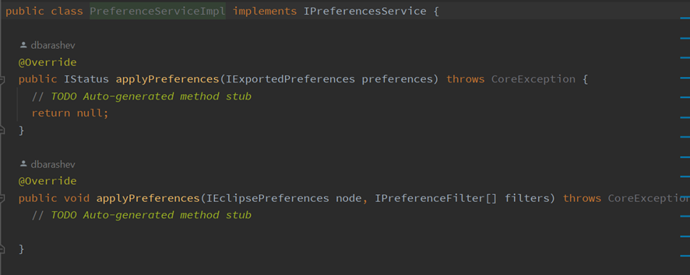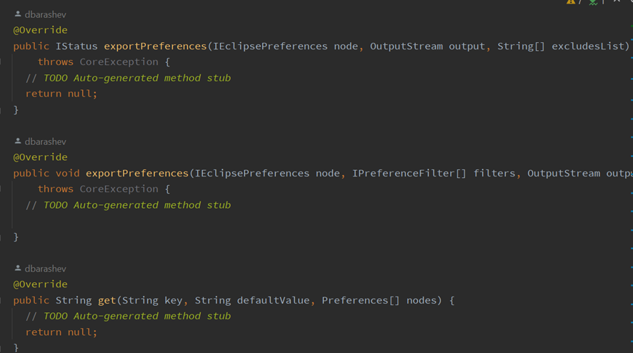

João Ribeiro’s Code Smells

Code Smell 1 - Dead Code

Location - ganttproject/src/main/java/net/sourceforge/ganttproject/chart/ChartModelImpl.java

Motive - Commented code from previous versions that isn’t being run and still is occupying space.

Solution - Delete the commented code.

Code snippet -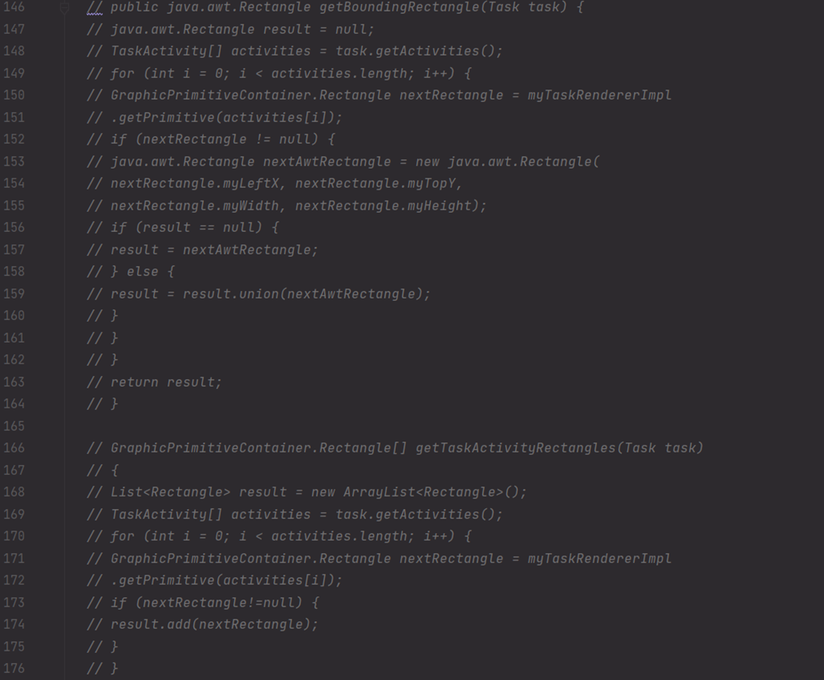

Code Smell 2 - Too many comments

Location - /ganttproject/src/main/java/biz.ganttproject/app/Internationalization.kt

Motive - Way too big of a comment for the size of the class.

Solution - Sum up some of the comments into a simpler and easy to read comment.

Code snippet -

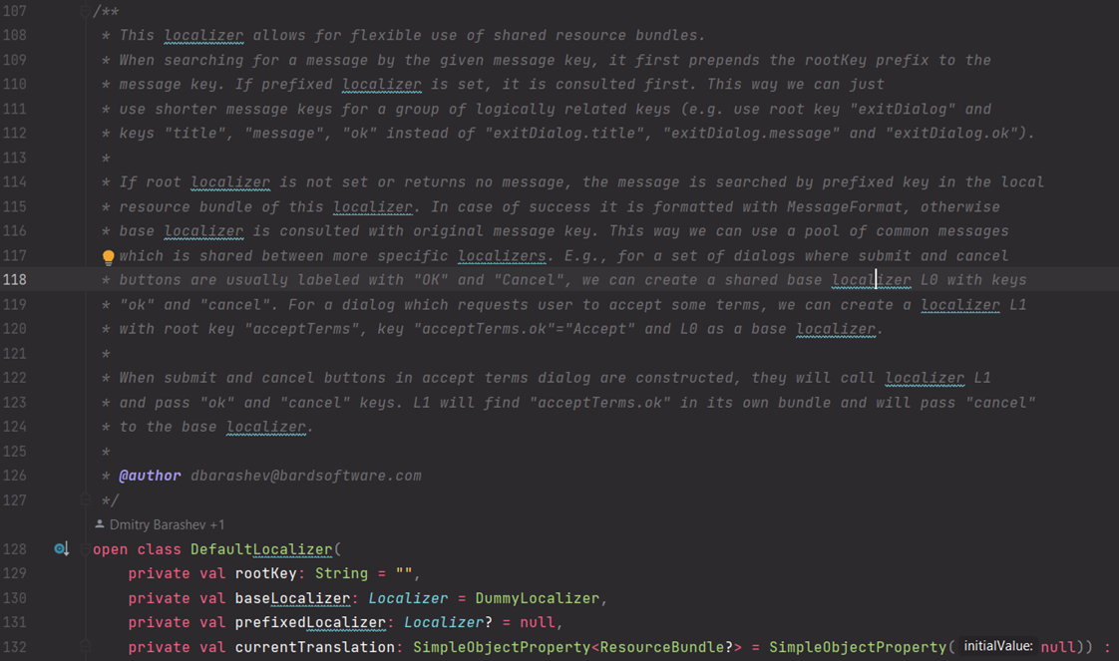

Code Smell 3 - Speculative Generality

Location - ganttproject/src/main/java/net/sourceforge/ganttproject/chart/ChartModelResource.java

Motive - An auto generated method without implementation inside it. Could lead to errors and, for now, it’s not doing anything.

Solution - Delete the method or fully implement it.

Code snippet -

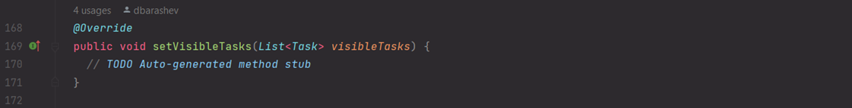

Pedro Gasparinho’s Code Smells

Code Smell 1 - Dead Code

Location - ganttproject\biz.ganttproject.core\src\main\java\biz.ganttproject\core\time\GanttCalender

Motive - When a method, such as this one, is commented it becomes obsolete since the functionality is either not supported anymore or implemented somewhere else, because of that the comments clutter the file where it’s written.

Solution - Given the fact that this piece of code is commented and there is no indication of a reminder that it is still being worked on, I suggest that we delete those lines to improve file size and that class’s readability.

Code snippet - 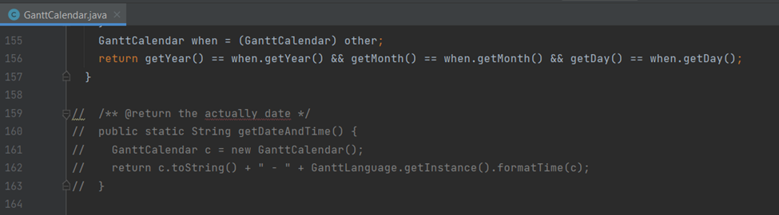

Code Smell 2 - Speculative Generality + Reminder Code

Location - ganttproject\ganttproject\src\main\java\net.sourceforge.ganttproject\PluginPreferencesImpl

Motive - The comment shown below on the codebase snippet indicates that the method is still being worked on, besides its auto generated, meaning that it must have been created by necessity of an Interface that the class implements.

Solution - In the previous version I suggested implementing this method, however it isn’t used as of now, meaning it’s an instance of a speculative generality code smell, so it’s not a very good solution. As suggested by my colleague Afonso we should delete this method, however we first have to delete it from the interface since it’s the only instance.

Code snippet - 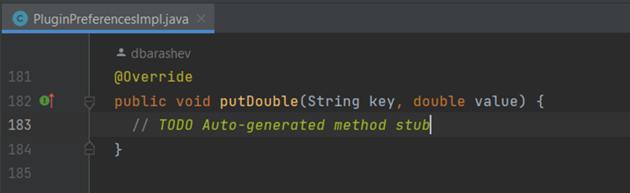

Code Smell 3 - Long Method

Location - ganttproject\biz.ganttproject.core\src\main\java\biz.ganttproject\core\time\impl\GPTimeUnitStack

Motive - When looking at this method, it’s easy to lose track of what it accomplishes and how so, not only because of the length by itself but also the accumulated complexity.

Solution - To refactor this piece of code what I suggest is to create a few auxiliary private methods to reduce the size of the original method and make it more digestible.

Code snippet -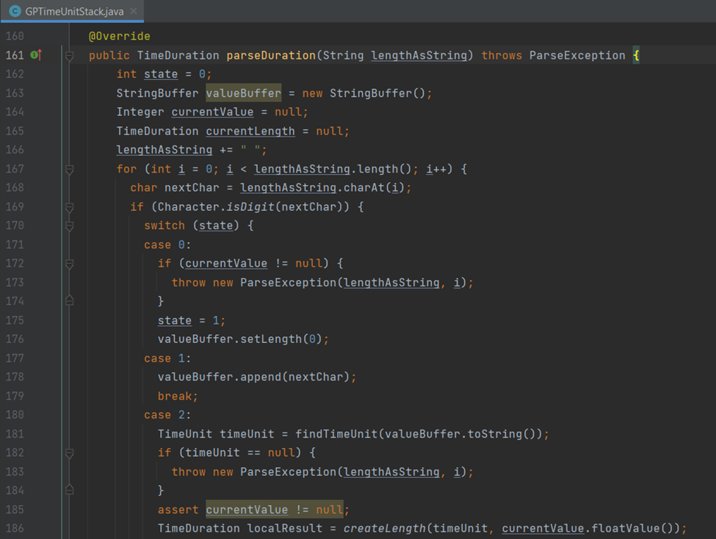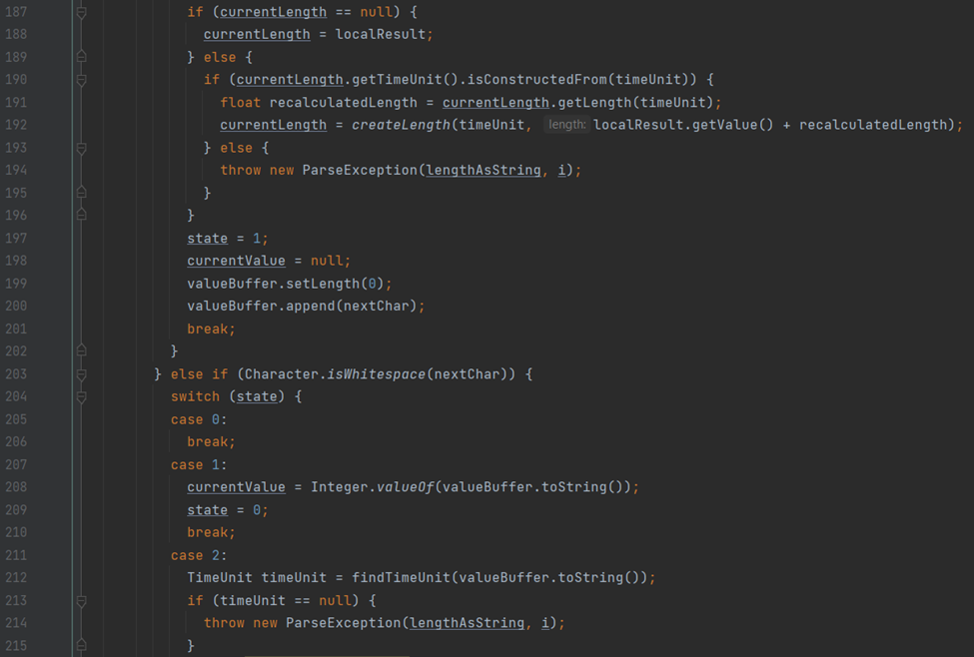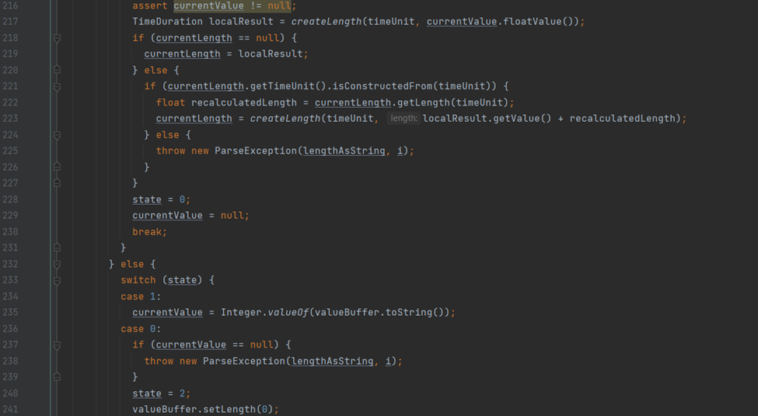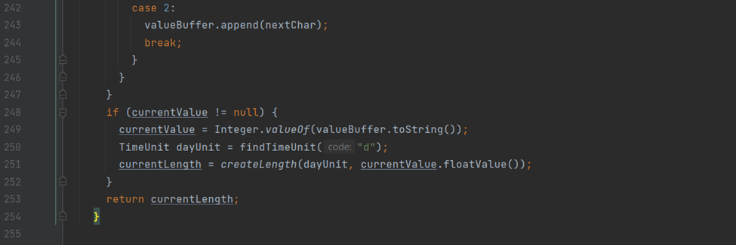

Tiago Meirim’ Code Smells

Code Smell 1 - Dead Code

Location - biz.ganttproject.core/src/main/java/biz/ganttproject/core/chart/grid/OffsetBuilderImpl.java

Motive - The method is commented so it is probably an idea for a code that was not finished or didn’t have purpose to the code at the moment.

Solution - Since the code is not being used in any part of the project, it should be erased to reduce code size and to make the class simpler.

Code snippet -

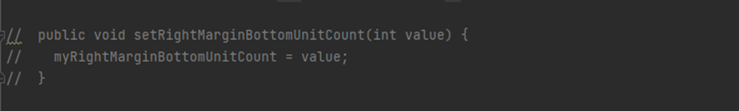

Code Smell 2 - Long Method

Location - biz.ganttproject.core/src/main/java/biz/ganttproject/core/chart/grid/OffsetBuilder.java

Motive - The constructor is not used to simplify the class giving it methods for every attribute that is saved in the class, it gives the code this unnecessary 53 lines.

Solution - Using the constructor as it should be we can initialize every attribute with only 12 lines saving us a total of 41 lines of code.

Code snippet -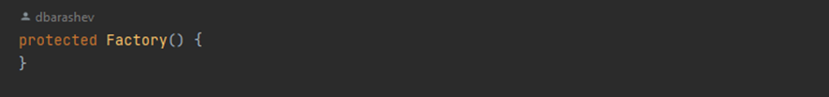

Code Smell 3 - Data Clumps

Location - biz.ganttproject.core/src/main/java/biz/ganttproject/core/chart/grid/OffsetBuilderImpl.java

Motive - There are a lot of parameters that appear numerous times in the methods.

Solution - Some of the parameters should be firstly stored in the class with the right conditions to be used and modified if needed like initialEnd.

Code snippet -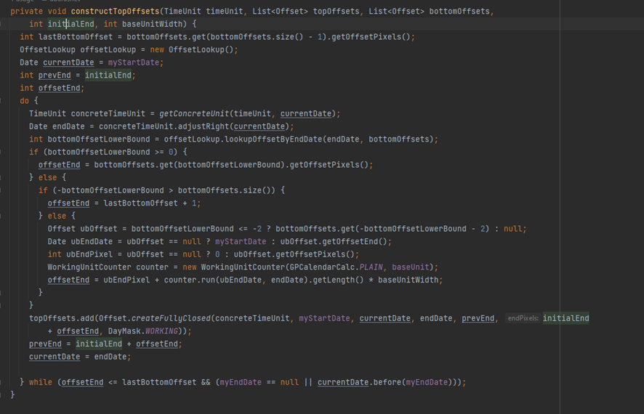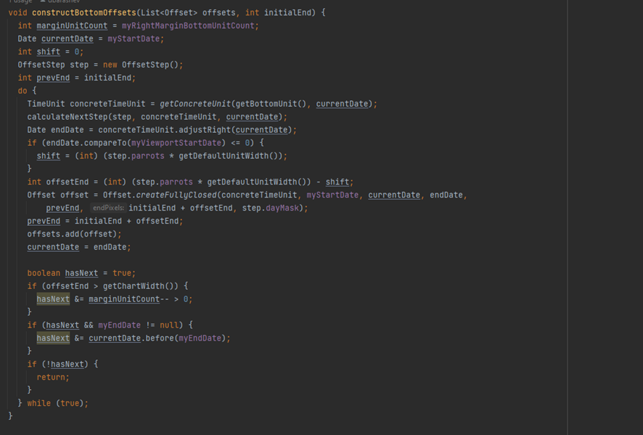

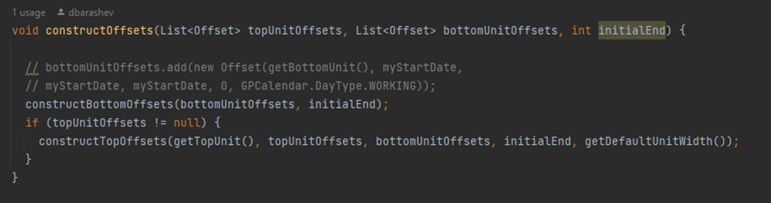

Afonso Nunes’ Code Smells

Code Smell 1 - No comments

Location - biz.ganttproject.core/src/main/java/biz/ganttproject/core/calendar/CalendarActivityImpl.java

Motive - When a class on a big project like in this case (or maybe even in a small one) has no comments, it becomes difficult to understand what it is supposed to do.

Solution - Add a simple class comment on what the class should actually be doing.

Code snippet -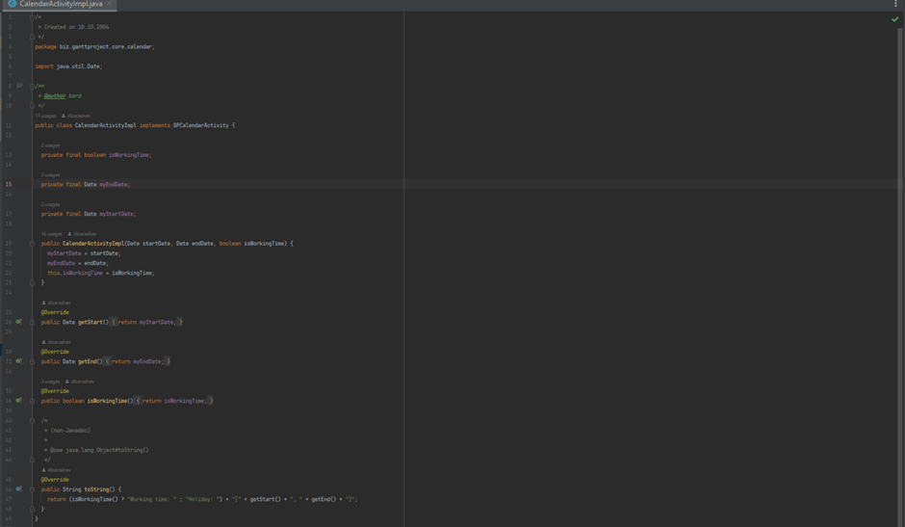

Code Smell 2 - Speculative Generality

Location - biz.ganttproject.core/src/main/java/biz/ganttproject/core/calendar/AlwaysWorkingTimeCalendarImpl.java

Motive - This piece of code indicates that the original writer implements an interface that has those methods declared, but he does not need to implement them in this specific class.

Solution - After a discussion with my colleague, he made me realize that I was making a foolish mistake and that I didn’t pay enough attention. Since we are already extending one abstract class we can just implement those methods there and delete them from the subclass by extending that existing abstract class.

Code snippet -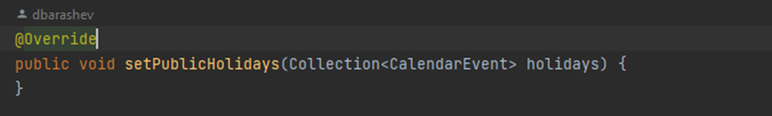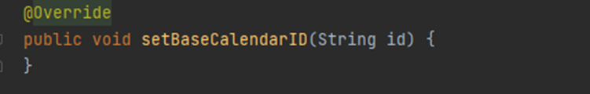

Code Smell 3 - Data Class

Location - biz.ganttproject.core/src/main/java/biz/ganttproject/core/calendar/CalendarActivityImpl.java

Motive - This is a very small class consisting of only data with no real functionality besides getter methods and a simple toString() method.

Solution - Defining these methods in another class where all this data is easily accessible from and where it makes more sense.

Code snippet -

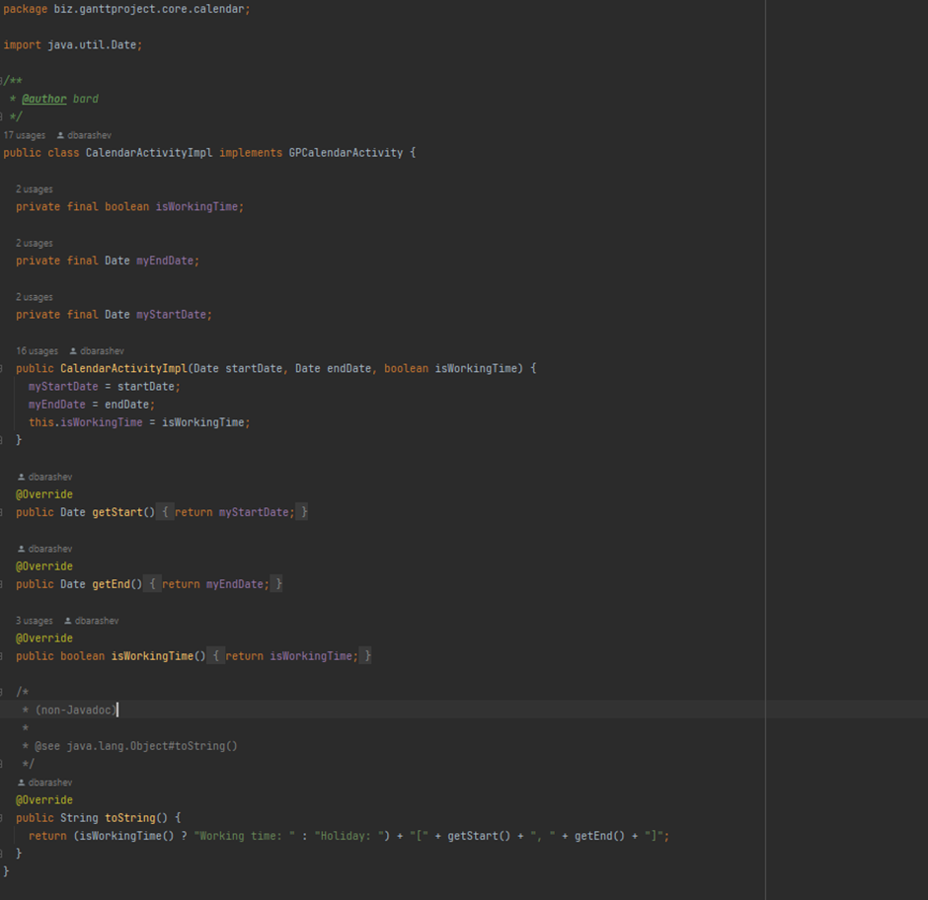

Chapter 3 – User Stories

Email Feature

User Story Email:

As a project manager I want to export the Gantt chart directly to all project collaborators' email so it's easier for everyone to access it.

Context:

The user would be allowed to export the gantt chart, that he is working on, attached into an email, in order to send it to all the co-workers involved in the project.

Email Use Case (by Afonso):

Email Use Case

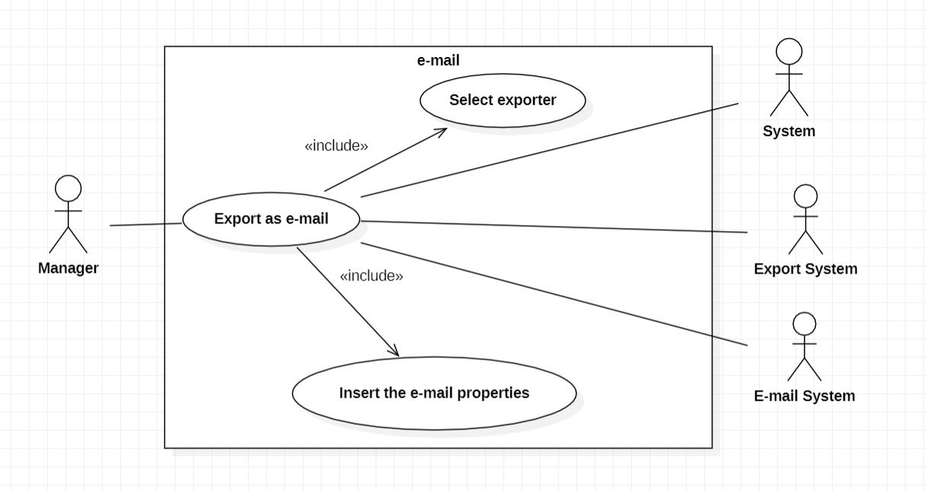

Export as e-mail:

Pre-condition: Have a working g-mail account with two step verification and after that get an application password provided by google;

Pre-condition: The system needs to have resources and those resources need e-mails.

The use case starts when the manager wants to export the project to all collaborators working on it and want to do it through the e-mail selecting then the e-mail button on the export interface. It makes use of all the systems presented on the diagram.

Post condition: None

Main actor:

* Manager.

Secondary actors:

* System.
* Export system.
* e-mail system.

Select exporter:

Pre-condition: None

The use case starts when the manager selects the exporter option on the graphic interface. He can also choose the location on the computer to save the project.

Post condition: None

Main actor:

* Manager.

Secondary actors:

* System.
* Export system.

Insert the e-mail properties:

Pre-condition: Having a working g-mail account with 2 step verification and an application password provided by google.

The use case starts when the manager inserts his account information and afterwards the e-mail subject and body.

Post condition: None

Main actor:

* Manager.

Secondary actors:

* System.
* e-mail system.

Review:

-->The diagram has an orthographic error;

-->In pre-condition to export as email, you should refer that you need a password provided by Google and the system needs to have resources with emails.

--> In my opinion, you should specify how "Select Exporter" and "Insert the email properties" work. I understand that you do that in the export email, but you should separate the descriptions.

Review by: Diogo Dias nº59731

- The use cases and actors look correct to me.

- The first phrase in the description sounds confusing,

you used the words select and export, or variations, too many times.

Review by: Pedro Gasparinho, 60590

--> The email functionality is well represented and with suficient explaning to understand what each method implements.

Review by Tiago Meirim, 60811

Trash Feature

User Story trash:

As a Gantt Project user I want to restore previously deleted tasks so that we can avoid remaking complex tasks that we actually need.

Context:

The user, instead of permanently eliminating a task, the task will be removed from the list and relocated into a new window named trash. In this new window, the user would be able to delete permanently the task in them or recover them, moving them into the original place, if possible.

**Trash Use Case**

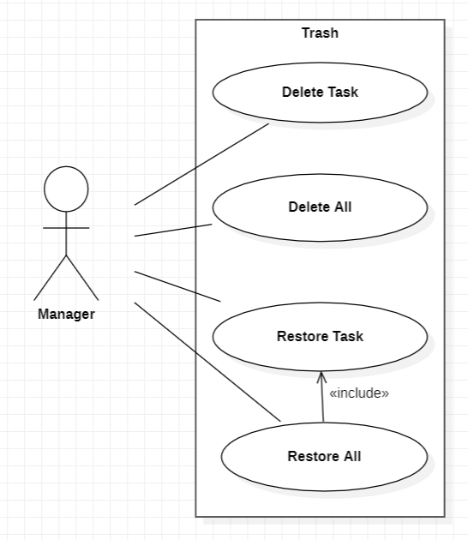

Delete Task

Pre-condition: At least one task must exist in the trash and at least one task must be selected.

The use case starts when the Manager clicks the delete button in the trash menu.

The selected task is deleted permanently.

Pos-condition: None

Primary Actors:

• Manager.

Secondary Actors:

• None.

Delete All

Pre-condition: At least one task must exist in the trash.

The use case starts when the Manager clicks the delete all button in the trash menu.

All the tasks present in the trash are permanently deleted.

Pos-condition: None

Primary Actors:

• Manager.

Secondary Actors:

• None.

Restore Task

Pre-condition: At least one task must exist in the trash and at least one task must be selected.

The use case starts when the Manager clicks the restore button in the trash menu.

The selected task is restored, with some of its properties, to the task list.

Pos-condition: None

Primary Actors:

• Manager.

Secondary Actors:

• None.

Restore All

Pre-condition: At least one task must exist in the trash.

The use case starts when the Manager clicks the restore all button in the trash menu.

All the tasks present in the trash are restored, with some of its properties, to the task list.

Pos-condition: None

Primary Actors:

• Manager.

Secondary Actors:

• None.

Reviews:

The include arrow direction seems to be the wrong way.

Reviewed by: Pedro Gasparinho 60590

I agree with the review made by my colleague Pedro Gasparinho.

The rest seems fine.

Reviewed by: Afonso Nunes 64862

I have nothing to add beyond what my colleagues said.

Reviewed by: Diogo Dias 59731

Trash Use Case Review

Everything seems according to what we discussed so i have nothing to add.

Reviewed by Tiago Meirim 60811

Chapter 4 – Use Cases (Gantt Project)

Afonso Nunes’ Use Cases

Project Use Case

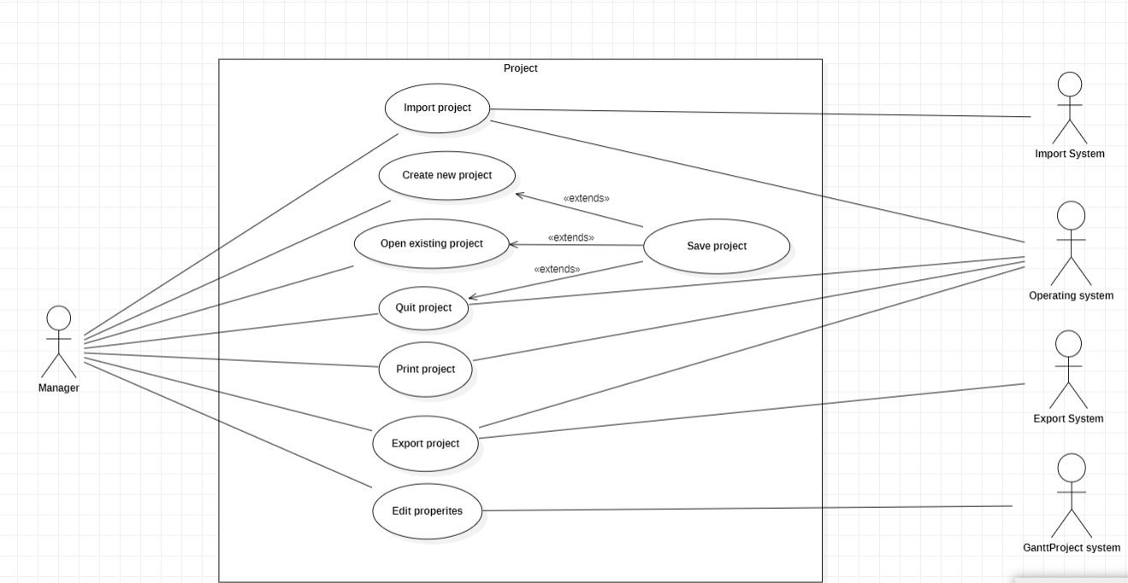

Import project:

Pre-condition: A Ganttproject saved on the computer.

The use case starts when the manager selects the option to import a Ganttproject. The manager will select the import system and then will select the location of the import from the system.

Post condition: None

Primary actor:

* Manager.

Secondary actors:

* Import System.
* Operating System.

Export project:

Pre-condition: None

The use case starts when the manager selects the option to export a Ganttproject. The manager will select the export system and then will select the location of the export from the system.

Post condition: None

Primary actor:

* Manager.

Secondary actors:

* Export System.
* Operating System.

Create new project:

Pre-condition: None

The use case starts when the manager selects the option to create a new project. The manager will select the project name, select its domain, and configure weekends and public holidays. If he’s working on a project, he can also save it.

Post condition: None

Primary actor:

* Manager.

Secondary actors:

* None

Open existing project:

Pre-condition: Already having a project

The use case starts when the manager selects the option to open an existing project. The manager will select the project location. If he’s working on a project, he can also save it.

Post condition: None

Primary actor:

* Manager.

Secondary actors:

* Operating System

Quit project:

Pre-condition: Already having a project

The use case starts when the manager selects the option to quit the project. The manager will select the project location on the system. If he’s working on a project, he can also save it.

Post condition: None

Primary actor:

* Manager.

Secondary actors:

* Operating System

Save project:

Pre-condition: None

The use case starts when the manager selects the option to save the project. The manager will select the project save location and the way he wants to save it as on the system.

Post condition: None

Primary actor:

* Manager.

Secondary actors:

* Operating System

Print project:

Pre-condition: None

The use case starts when the manager selects the option to print the project. The manager will select the printing options and can also choose to save it on the system.

Post condition: None

Primary actor:

* Manager.

Secondary actors:

* Operating System

Edit project:

Pre-condition: None

The use case starts when the manager selects the option to edit the project properties. The manager will then be able to edit its name, description, calendar, and resource roles.

Post condition: Save the editions.

Primary actor:

* Manager.

Secondary actors:

* Ganttproject System

Review:

--> I think you should specify in Use Case Diagram that System refers to Operating System where GanttProject is running.

--> You should merge the use cases "Save Project" and "Save Current Project" in one use case.

--> You have some orthographic errors in your descriptions;

-->I think you should refer to the pre-condition of "Import System" that you need to have a GanttProject saved on your computer.

--> Edit project uses other features of GanttProject that are not specified in this use case. So you should add a GanttProject System to ensure these features.

Review by: Diogo Dias nº59731

Diogo Dias’ Use Cases

Tasks Use Case

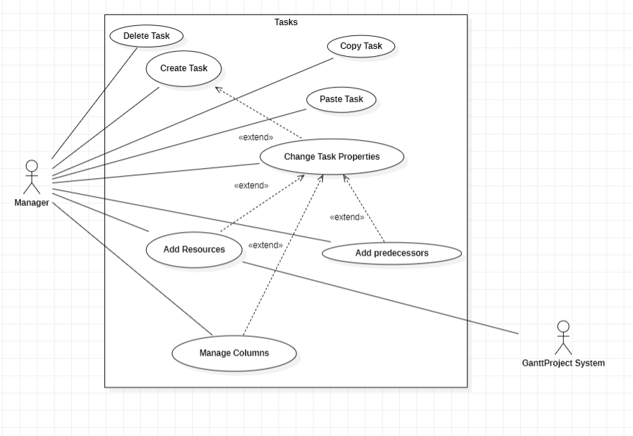

Delete Task

Pre-condition: At least one task exists.

The use case starts when the manager selects the option to delete a task. The system will delete a Task that was created previously.

Post condition: None

Primary Actor:

* Manager.

Secondary Actor:

* None.

Copy Task

Pre-condition: At least one task exists.

The use case starts when the manager selects the option to copy a task. The system will copy a Task that was created previously.

Post condition: None

Primary Actor:

* Manager.

Secondary Actor:

* None.

Paste Task

Pre-condition: Copy Task was performed.

The use case starts when the manager selects the option to paste a task. The system will paste a Task that was created previously. The system after this operation has two equal tasks.

Pos-condition: None

Primary Actor:

* Manager.

Secondary Actor:

* None.

Create Task

Pre-condition: None

The use case starts when the manager selects the option to create a task. The system will create a default Task. The task is a job that should be done in a period by some workers.

Post condition: None

Primary Actor:

* Manager.

Secondary Actor:

* None.

Change Task Properties

Pre-condition: At least one task exists.

The use case starts when the manager selects the option properties task. The system will show some properties that can be changed (name, dates, priority, progress, color, fill and add a website). After the manager set some properties, the system will show a task that is different from other tasks.

Pos-condition: None

Primary Actor:

* Manager.

Secondary Actor:

* None.

Add Resource

Pre-condition: The resource needs exist in the system and at least one task.

The use case starts when the manager selects additional resources for a task. The GanttProject System is responsible for resources. The system will allow the manager to specify who should do the task.

Pos-condition: None

Primary Actor:

* Manager.

Secondary Actor:

* GanttProject System.

Add Predecessors

Pre-condition: Exist at least two tasks.

The use case starts when the manager selects Predecessors in task properties. The system will allow the manager to select another task. The task selected initially, that will change his properties can only begin when the other task chosen finishes.

Pos-condition: None

Primary Actor:

* Manager.

Secondary Actor:

* None.

Manage Columns

Pre-condition: At least one task exists

The use case starts when the manager selects Manage Columns in task properties The system allows the manager and some properties specific to the task.

Pos-condition: None

Primary Actor:

* Manager.

Secondary Actor:

* None.

Review:

* I agree with my coleague, every action that can be made for task is well represented and explained properly, with every pre codition and post condition.

Reviewed by Tiago Meirim 60811.

João Ribeiro’s Use Cases

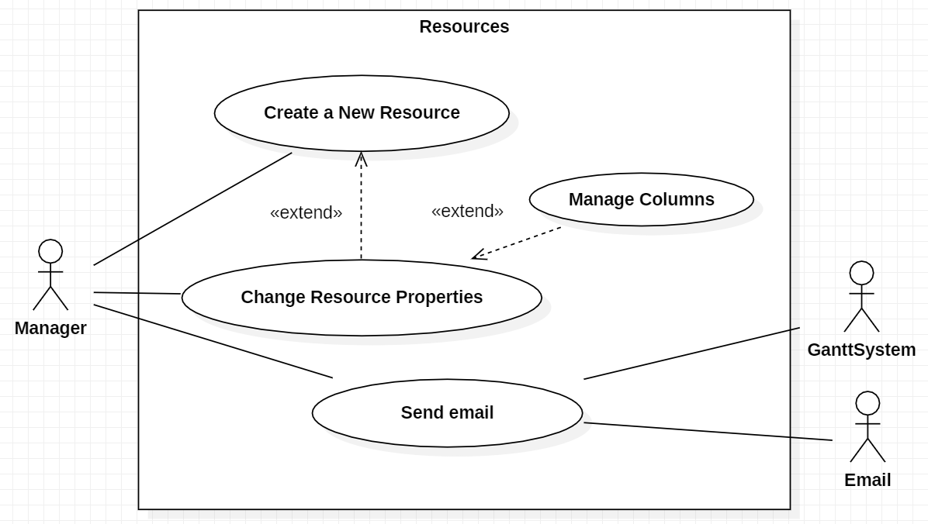**Resources Use Case**

Create New Resource

Pre-condition: None

Creates a new Resource and add it to the resource list.

The use case starts when the Manager clicks the add resource button.

In the resource creation, the Manager needs to add a name, a phone, a mail, a payment rate and select a default role.

The resource can be created with days off.

Pos-condition: None

Primary Actors:

• Manager.

Secondary Actors:

• None.

Change Resource Properties

Pre-condition: At least one resource exists.

The use case starts when the Manager clicks the resource properties button.

Change the properties of selected Resource in the resource list.

The Manager can change the name, phone, mail, payment rate and default role of any resource.

The Manager can also change the days off the resource has.

Pos-condition: None

Primary Actors:

• Manager.

Secondary Actors:

• None.

Send Email

Pre-condition: At least one resource exists.

The use case starts when the Manager clicks the send email button.

The Manager, using the System and the Help of the Email subsystem, sends an email to the selected Resource mail.

Pos-condition: None

Primary Actors:

• Manager.

Secondary Actors:

• GanttSystem, Email.

Manage Columns

Pre-condition: None

The use case starts when the Manager goes to the change properties and opens the manage columns tab.

The Manager can now manage the columns to be presented in the resource list.

Pos-condition: None

Primary Actors:

• Manager.

Secondary Actors:

• None.

Resource Use Case

Agree with the diagram

Reviewed by: Pedro Gasparinho 60590

Pedro Gasparinho’s Use Cases

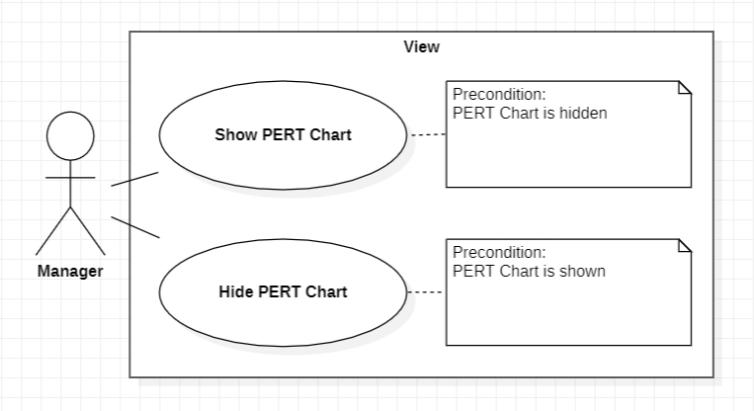View Use Case

Show PERT Chart:

Precondition – The manager cannot visualize a page containing a PERT chart.

The use case starts when the manager selects the “PERT Chart” option under the “View” tab in the toolbar and the system converts the Gantt chart into a PERT chart displays it in a new page. A PERT chart is a visual tool used in project management to present and track a timeline containing tasks.

Postcondition – None.

Primary Actor:

* Manager.

Secondary Actor:

* None.

Hide PERT Chart:

Precondition – The manager can visualize a page containing a PERT chart.

The use case starts when the manager selects the “PERT Chart” option under the “View” tab in the toolbar and the system will close the previously opened page showing the PERT chart.

Postcondition – None.

Primary Actor:

* Manager.

Secondary Actor:

* None.

View Use Case

I agree with the diagram and description made by my colleague.

Reviewed by: Afonso Nunes 64862

Task Hierarchy Use Case

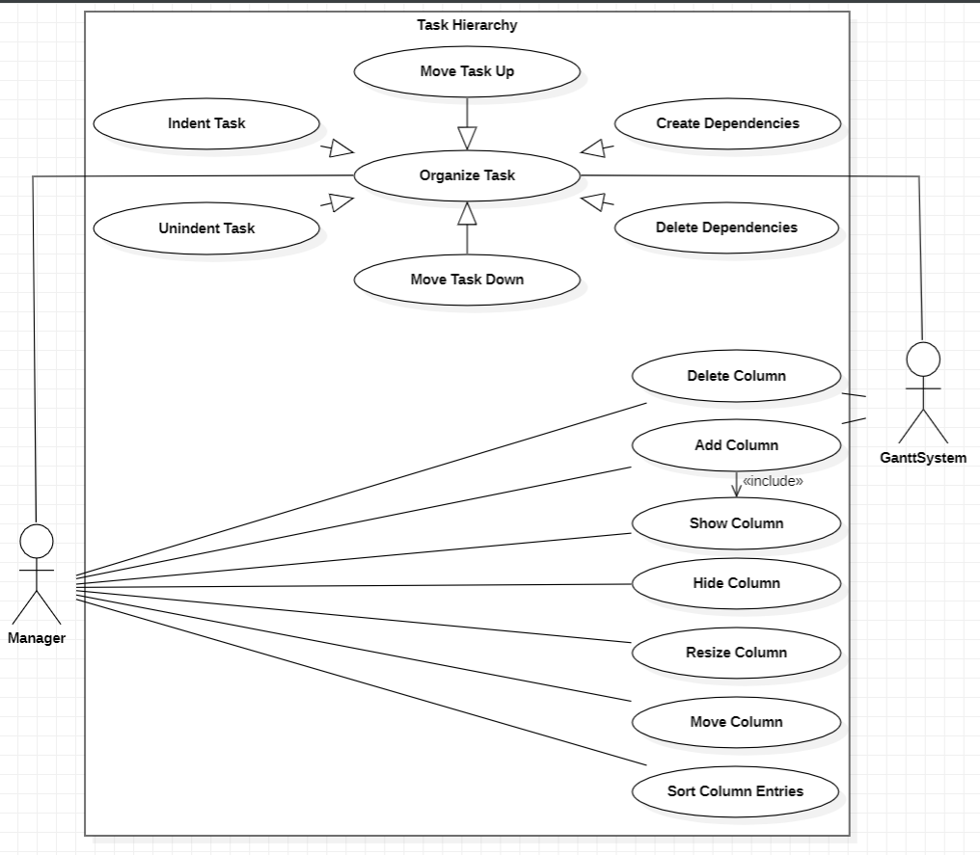

Note for all use cases: The GanttSystem interacts with the task hierarchy when it involves other objects from the project app (for ex: tasks).

Organize Task:

Precondition – The system needs to have a minimum of two tasks and at least one of them is selected.

The use case starts when the manager clicks one of six buttons on top of the task hierarchy sidebar and the system acts accordingly.

Postcondition – None.

Primary Actor:

* Manager.

Secondary Actor:

* Gantt System.

Move Task Up:

Precondition – Inherits preconditions from Organize Task. The selected task must not be the topmost task in the hierarchy.

The use case starts when the manager clicks on the move up button. The system now showcases the selected task one position above its initial one.

Postcondition – None.

Primary Actor:

* Manager.

Secondary Actor:

* Gantt System.

Move Task Down:

Precondition – Inherits preconditions from Organize Task. The selected task must not be the downmost task in the hierarchy.

The use case starts when the manager clicks on the move down button. The system now showcases the selected task one position below its initial one.

Postcondition – None.

Primary Actor:

* Manager.

Secondary Actor:

* Gantt System.

Indent Task:

Precondition – Inherits preconditions from Organize Task. The selected task must not be the topmost task. The selected task must be at the same level (horizontally) as one of the tasks above it.

The use case starts when the manager clicks on the indent button. The system now showcases the selected task one level (horizontally) forward, being nested to the one above it.

Postcondition – None.

Primary Actor:

* Manager.

Secondary Actor:

* Gantt System.

Unindent Task:

Precondition – Inherits preconditions from Organize Task. The selected task must not be the topmost task. The selected task must be one level forward (horizontally) to the one directly above it.

The use case starts when the manager clicks on the unindent button. The system now showcases the selected task one level (horizontally) backwards, stops being nested to the one above it.

Postcondition – None.

Primary Actor:

* Manager.

Secondary Actor:

* Gantt System.

Created Dependencies:

Precondition – Inherits preconditions from Organize Task. At least two tasks are selected. The two tasks must not be nested to one another. The two tasks must not already have a dependency.

The use case starts when the manager clicks on the create dependencies button. The system now showcases a dependency going from one task to another.

Postcondition – None.

Primary Actor:

* Manager.

Secondary Actor:

* Gantt System.

Delete Dependencies:

Precondition – Inherits preconditions from Organize Task. At least two tasks are selected. The two tasks must not be nested to one another. The two tasks must already have a dependency.

The use case starts when the manager clicks on the delete dependencies button. The system now does not show the dependency going from one task to another, as it does not exist anymore.

Postcondition – None.

Primary Actor:

* Manager.

Secondary Actor:

* Gantt System.

Delete Column:

Precondition – The manager must select an existing column while managing the columns. The selected column must be user-made.

The use case starts when the manager clicks the Delete button while managing the columns. The system deletes the selected column from the tasks.

Postcondition – None.

Primary Actor:

* Manager.

Secondary Actor:

* Gantt System.

Add Column:

Precondition – None.

The use case starts when the manager clicks the Add button while managing the columns. The system adds a new column to the tasks.

Postcondition – None.

Primary Actor:

* Manager.

Secondary Actor:

* Gantt System.

Show Column:

Precondition – The selected column must not be visible.

The use case starts when the manager clicks the Show button while managing the columns. The column is visible on the sidebar hierarchy to the manager.

Postcondition – None.

Primary Actor:

* Manager.

Secondary Actor:

* None.

Hide Column:

Precondition – The selected column must be visible.

The use case starts when the manager clicks the Hide button while managing the columns. The column is not shown on the sidebar hierarchy to the manager.

Postcondition – None.

Primary Actor:

* Manager.

Secondary Actor:

* None.

Resize Column:

Precondition – The selected column must be visible.

The use case starts when the manager clicks the Resize button on a column. The column’s size is automatically adjusted.

Postcondition – None.

Primary Actor:

* Manager.

Secondary Actor:

* None.

Move Column:

Precondition – The selected column must be visible.

The use case starts when the manager clicks and holds on a column. The column is moved sideways and switches places with other columns based on the movement made by the manager.

Postcondition – None.

Primary Actor:

* Manager.

Secondary Actor:

* None.

Sort Column Entries:

Precondition – The selected column must be visible. The selected column must not be the name column.

The use case starts when the manager double clicks a column. The column is sorted based on the indentation, the value being sorted and the “direction” of sorting.

Postcondition – None.

Primary Actor:

* Manager.

Secondary Actor:

* None.

Task Hierarchy Use Case

I agree with the diagram and description made by my colleague.

He could, however, make it more clear that the GanttSystem actor

does not participate in operations like "Show Column", "Hide Column",

"Resize Column", "Move Column", "Sort Column Entries" because they do not edit

the task properties in itselt.

Reviewed by: Afonso Nunes 64862

Seen Both reviews. Added a note to clarify the task hierarchy use case. By: Pedro Gasparinho 60590

Tiago Meirim’s Use Cases

Calendar Use Case

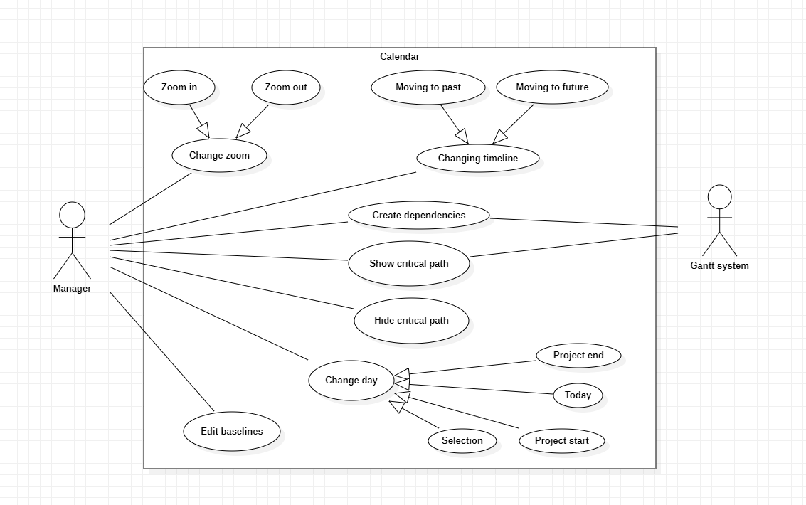

Edit baselines

Pre-condition: None

The use case starts when the button is clicked and gives the option to change the size and color of the baselines.

Primary Actor:

* Manager.

Secondary Actor:

* None.

Change day

The use case starts when the selected date is chosen so it will let the manager change the specific date the calendar is displaying.

Primary Actor:

* Manager.

Secondary Actor:

* None.

Project end

Pre-condition: None.

The use case starts when the manager chooses the project end and shows the calendar where the project has ended.

Primary Actor:

* Manager.

Secondary Actor:

* None.

Today

Pre-condition: None.

The use case starts when the manager chooses today and shows the calendar in the present day.

Primary Actor:

* Manager.

Secondary Actor:

* None.

Project Start

Pre-condition: None.

The use case starts when the manager chooses project start and shows the calendar where the project has started.

Primary Actor:

* Manager.

Secondary Actor:

* None.

Selection

Pre-condition: None.

The use case starts when the manager chooses selection and shows the calendar where the selected task is.

Primary Actor:

* Manager.

Secondary Actor:

* None.

Show critical path

Pre-condition: Critical path is not shown.

The use case starts when the manager chooses the button show critical path and shows the critical path of our tasks using the Gantt system.

Primary Actor:

* Manager.

Secondary Actor:

* Gantt system.

Hide critical path

Pre-condition: None

The use case starts when the manager chooses the button hide critical path and stops showing the critical path of our tasks

Primary Actor:

* Manager.

Secondary Actor:

* None.

Create dependencies

Pre-condition: There needs to be at least 2 tasks to make a dependency.

The use case starts when the manager selects a task and links it with another one by an arrow, so it becomes dependent of the first task that was selected.

Primary Actor:

* Manager.

Secondary Actor:

* Gantt System.

Change timeline

The use case starts when the manager uses one of the buttons that lets the calendar go more

to the future or the past.

Primary Actor:

* Manager.

Secondary Actor:

* None.

Moving to past

Pre-condition: None.

The use case starts when the manager uses the button move to past that lets the calendar go more to the past.

Primary Actor:

* Manager.

Secondary Actor:

* None.

Moving to future

Pre-condition: None.

The use case starts when the manager uses the button move to future that lets the calendar go more to the future.

Primary Actor:

* Manager.

Secondary Actor:

* None.

Change zoom

The use case starts when the manager uses the buttons to zoom in or zoom out so it makes the calendar be further away or closer.

Primary Actor:

* Manager.

Secondary Actor:

* None.

Zoom in

Pre-condition: None.

The use case starts when the manager uses the button zoom in and makes the calendar closer so u can see in more detail the days.

Primary Actor:

* Manager.

Secondary Actor:

* None.

Zoom out

Pre-condition: None.

The use case starts when the manager uses the button zoom out and makes the calendar further so u can see the full picture better.

Primary Actor:

* Manager.

Secondary Actor:

* None.

Calendar Use Case (V2)

I agree with my college with the sctructure of the use case.

The descriptions could be more extense.

Nothing else to point out.

Review by: João Ribeiro 60127

Chapter 5 – Metrics

Afonso Nunes’ Metrics

Line of Code Metrics

Javadoc Lines of Code (JLOC)

Calculates the number of lines of Javadoc comments in each method. Whitespace is not counted.

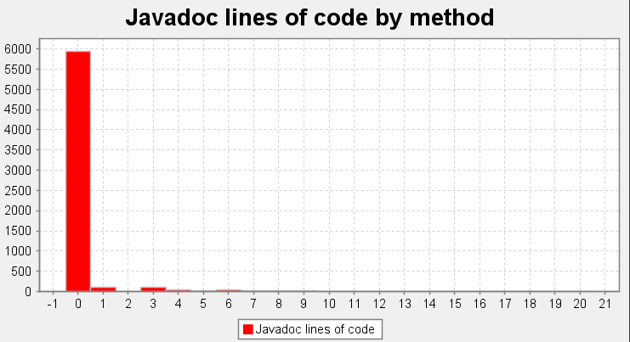

As we can observe from the chart, almost all methods are not documented as Javadoc, which does not help in understanding the code, as was mentioned in our phase 1 report, where we found one instance of the no comments code smell, specifically in the CalendarActivityImpl class. On the contrast the makeCompactGrid method in the SpringUtilities class has the most JavaDoc line in the whole project with 20 lines.

Lines of Code (LOC)

Calculates the lines of code in each method. Lines of code of anonymous or local classes and their methods are included in the count of the enclosing method. Lines with only comments are counted, but lines with only whitespace are not.

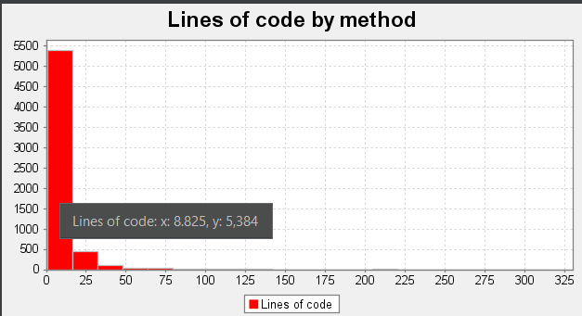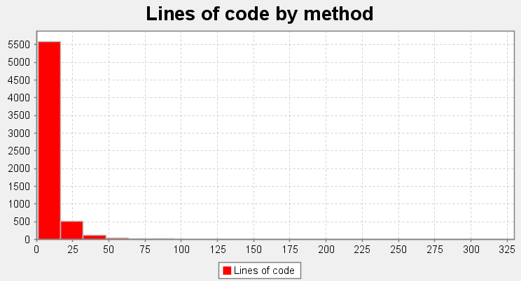

Analyzing the charts, we conclude that most methods have about 9 lines of code, however we can see some instances of lengthy methods, some even surpassing the 100 lines, justifying how we easily found a couple of instances of long methods for the code smells in the first phase. The method with the most lines of code is PrintPreview, which is one constructor from the PrintPreview class.

Line_of_Code metrics Review

--> There is indeed a no comment in CalendarActivityImpl where we can see the code smell and from the datagram we can conclude there is a lot of non commented features.

--> The average lines of code per method which is about 9 tells us that there is a lot of not complicated methods, however like my coleague mentioned there is some methods that are extremely big with about 100 lines of code which makes the code really hard to follow.

Review by: Tiago Meirim 60811

Diogo Dias’ Metrics

Chidamber-Kemerer metrics

Coupling Between Objects (CBO)

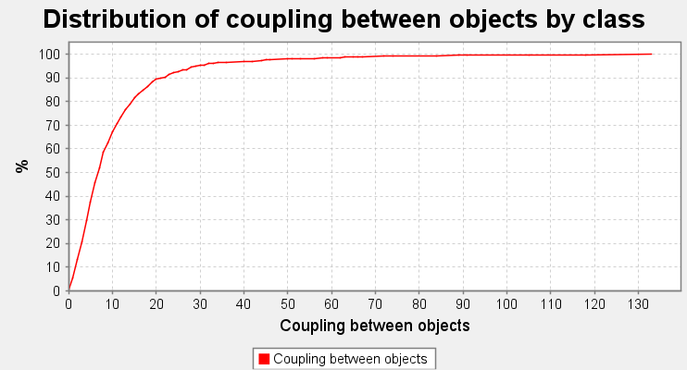Coupling is a measure of how dependent two or more classes are from one another. Heavy coupling is not advised as it may lead to various code smells.

After analyzing the Gantt Project with this metric, we reach a conclusion that about 70% of the classes are not tightly coupled between one another, only receiving a CBO score of up 10. However, about 30% is still a significant proportion of the project, meaning that this portion of the code might lead to code smells such as feature envy, inappropriate intimacy and message chain. One example being the GanttLanguage class, with a score of 133.0, which uses the Locale class too often.

Lack of cohesion methods (LCOM)

Cohesion measures how well the elements of a class are integrated in satisfying its goals, for example by sharing variable use, resulting in classes that are difficult to separate into smaller ones. The lack of cohesion is not recommended as it might be necessary to look in other parts of the code when modifying a method, in the long-term becomes difficult to maintain, test and reuse.

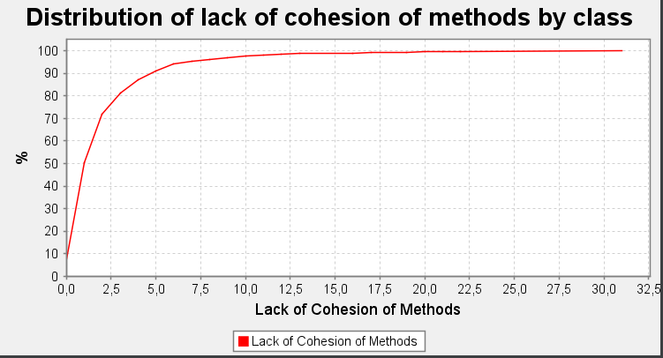As we can see in the image above, about 75% of the classes are tightly cohesive (with a maximum lack of cohesion score of 2.5), meaning that their methods are mostly all involved in satisfying their goals. However, 25% of the classes start to lack cohesion which might result in code smells, mainly divergent classes and shotgun surgery. A potential trouble spot is the GanttProjectBase Class with a score of 31.0, this might happen because it uses a lot of distinct objects to achieve different tasks independently from one another, causing a lack of cohesion.

Metrics Review:

* You should add a few examples of classes and their scores in those metrics.
* While the the ExporterToCSV class contains the message chain code smell, it only has a CBO score of 9.0, which is a low value comparared to other classes in the project, so it might not be the best example.

Reviewed by: Pedro Gasparinho, 60590

Thank you, Pedro, I think that is correct now.

By: Diogo Dias

João Ribeiro’s Metrics

Martin’s packaging metrics

Efferent Coupling (Ce)

“Calculates the number of Efferent Couplings for each package. An Efferent Coupling is a reference from a class or interface internal to the package to a class or interface external to the package. That is Afferent Couplings are Arriving references, Efferent Coupling are Exiting or Escaping references. References to test classes and library classes are not included.”

In summary, this metric is used to measure how many other packages a package depends on.

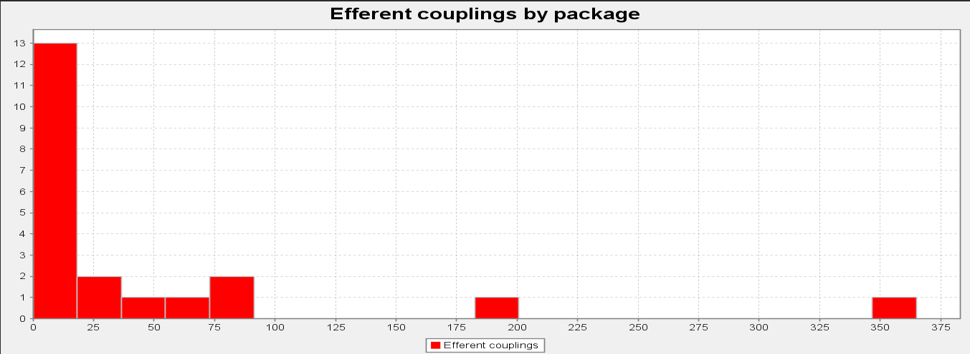

After running this metric trough, the Gantt Project, we conclude that many packages are not dependent on, but some are really relied on. This means that if any problem / changes / bugs are present in those, it could alter a lot on the whole program.

The net.sourceforge.ganttproject.task.algorithm package is the one with the biggest score of 365.

Afferent Coupling (Ca)

“Calculates the number of Afferent Couplings for each package. An Afferent Coupling is a reference from a class or interface external to the package to a class or interface internal to the package. That is Afferent Couplings are Arriving references, Efferent Coupling are Exiting or Escaping references. References from test classes and library classes are not included.”

In summary, this metric is used to measure how much a package depends on another package.

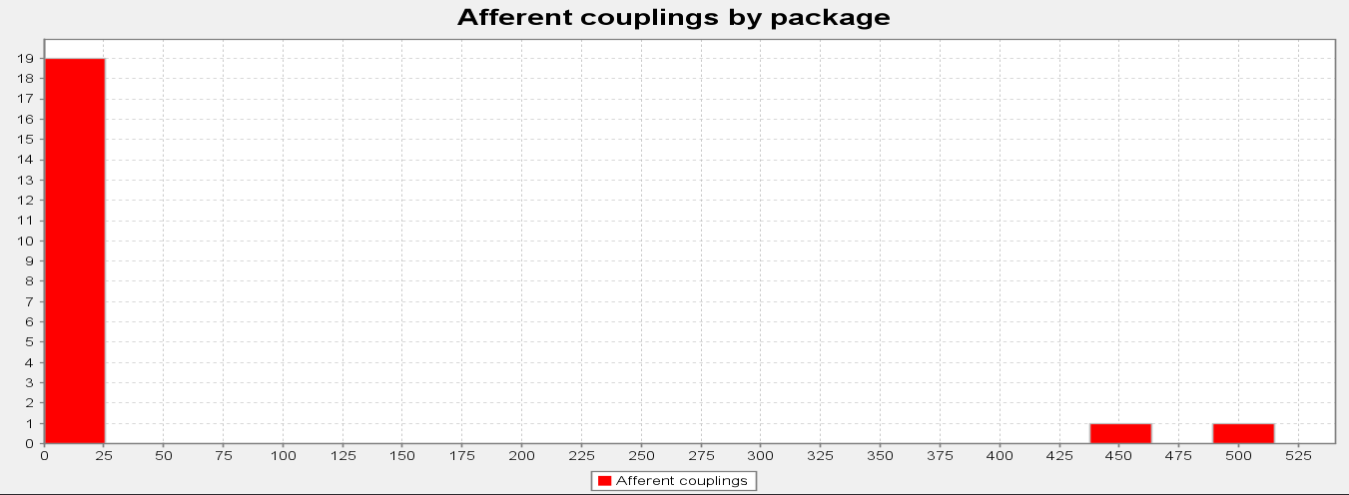

As we can see above, the data of this metric about the Gantt Project indicates that not many packages depend on another package, but some of them are dependent on various packages. With this latest part of the data, we can conclude that there are packages that can be easily compromised because they are dependent on so many other packages.

The net.sourceforge.ganttproject.test.task package is the one with the biggest score of 444.

Instability (I)

“Calculates the Instability of a package. The Instability of a package is defined as the package's Efferent Couplings divided by the sum of the package's Afferent and Efferent Couplings (Ce÷(Ca+Ce)). This metric has a range of [0,1]. I=0 indicates a maximally stable package, I=1 indicates a maximally unstable package.”

In summary, this metric tells us is how stable a package is.

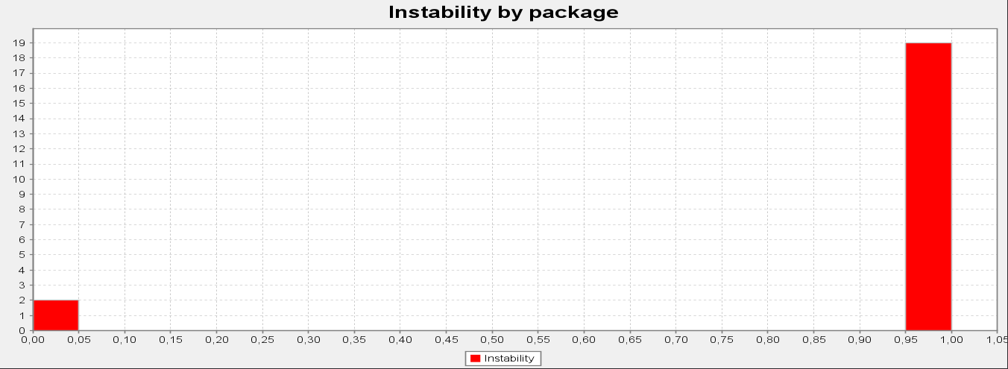

In conclusion with this last metric, the Gantt project is very stable as a whole, but some of its packages are very instable.

The net.sourceforge.ganttproject and the net.sourceforge.ganttproject.test.task packages are the ones with the lowest score (0,00 and 0,02, respectfully), meaning, they are the most instable ones.

Review

Firstly I think the data was rightly collected.

Secondly I also think that the analysis was well done.

I would only word it a little better so it's less

confusing.

Reviewed by: Afonso Nunes 64862

Pedro Gasparinho’s Metrics

Dependency metrics

Cognitve Complexity (CogC)

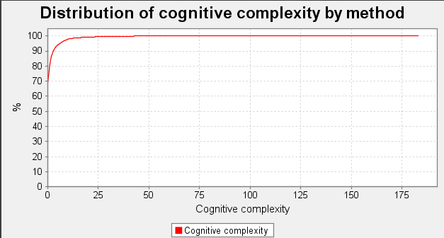Measures how difficult it is to understand intuitively a piece of code. The cognitive complexity is increased by many factors, such as the lack of familiarity with the tools used or the problem domain, large pieces of code or high essential complexity.

Surprisingly, the methods are easy to understand as per the graphic, meaning that the project contains relatively few long methods and possibly few god classes, which may lead to fewer bugs and less rework. The startElement method from the GanttXMLOptionsParser is the most complex method in the project from a Cognitive complexity perspective, this is because the method is very long and deals with the format of XML files.

Cyclic Complexity (v(C))

Calculates the amount of distinct execution paths needed to test extensively a method. Execution paths depend on the number of if’s, switches, loops, condition expressions and others.

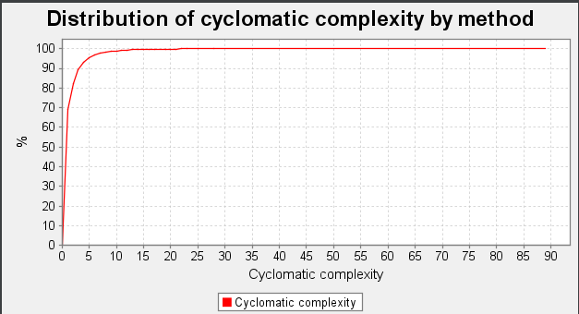

As the graphic shows, the majority of methods have a cyclomatic complexity of one, meaning that they can be tested in only one execution path. The fewer the number of execution paths the easier it might be to test a program. The startElement method from the GanttXMLOptionsParser is the most complex method in the project from a Cyclomatic complexity perspective, this is because the method is very long and contains many if’s and a switch statement.

Reviews:

The report made by my college is well explained and well presented.

I agree with the description of the metrics and the graph that are presented.

Reviewed by: João Ribeiro 60127

Tiago Meirim’s Metrics

Dependencies metrics

Class metrics

Cyclic

Calculates the number of classes or interfaces which each class directly or indirectly depends on, and which in turn directly or indirectly depend on it. Such cyclic dependencies may result in code which is difficult to understand and test.

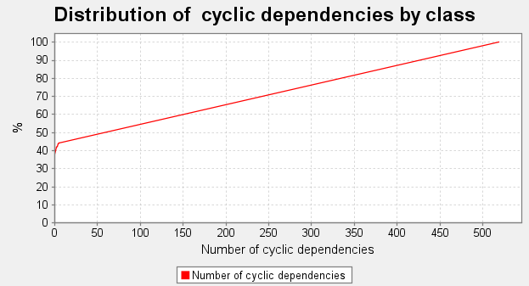

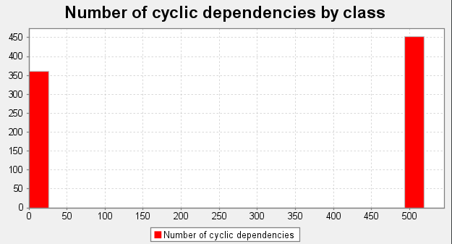As we can confer the chart shows that more than 50% of the classes have at least 50 cyclic dependencies, which is a very bad stat for the project.

The chart above shows us, that there is a big cluster of classes that heavily depend (directly or indirectly) on one another.

Distribution of dependencies by class

Calculates the number of classes or interfaces which each class directly depends on.

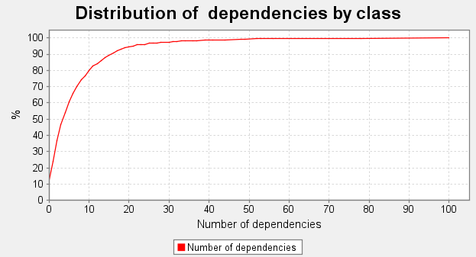

The graph shows us that 80% of the classes depend directly on at most 10 other classes. The GanttProject class is the one that has the most direct dependencies at 100, this is to be expected as it is the system class of the project.

Reviews:

--> I think you collect the wrong data. I confirm in my project and Pedro's project the data. If you want, I can give you what we think is correct.

--> The data analysis I think, is correct just need to adapt to new data.

Review by: Diogo Dias, nº59731

Seen by Tiago Meirim 60811 and corrected the errors

Chapter 6 – Video

The following link will redirect to the video explaining our features.

<https://youtu.be/wOob7O8_zvY>